1. **Sum of Two Numbers**  
   Write a program that takes two integers as input and calculates their sum using a function. Pass the integers to the function using call by value.

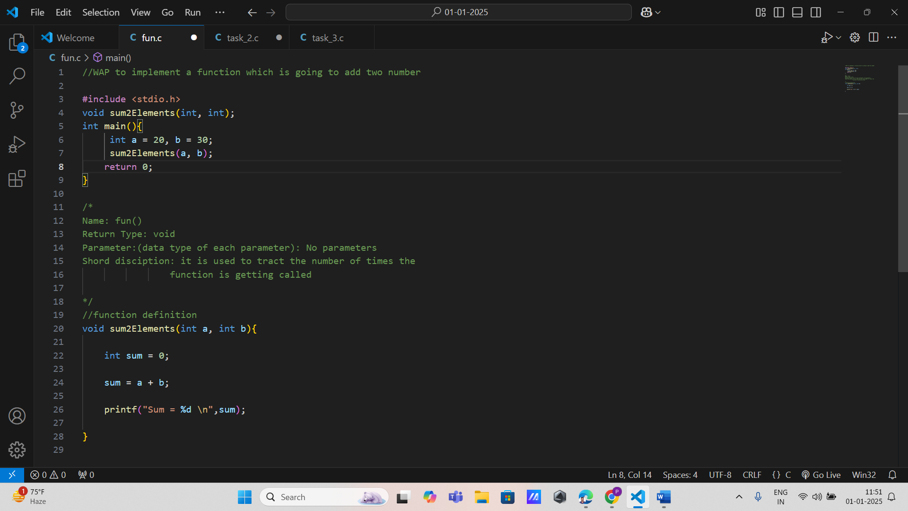

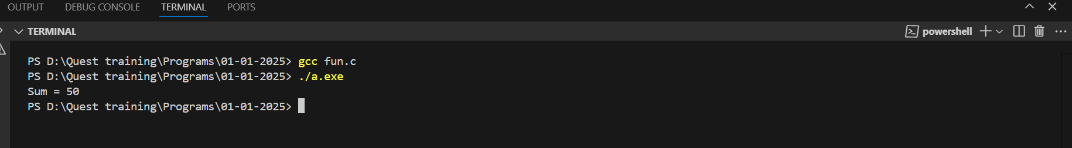

1. **Swap Two Numbers**  
   Write a program to swap two numbers using a function. Observe and explain why the original numbers remain unchanged due to call by value.

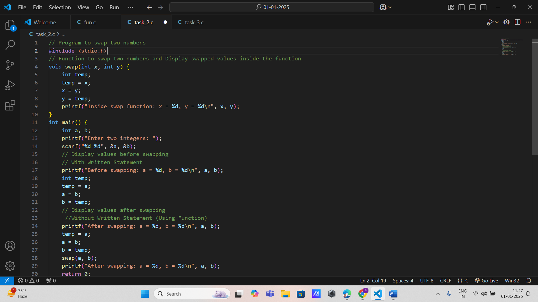



1. **Find Maximum of Two Numbers**  
   Implement a function that takes two integers as arguments and returns the larger of the two. Demonstrate how the original values are not altered.

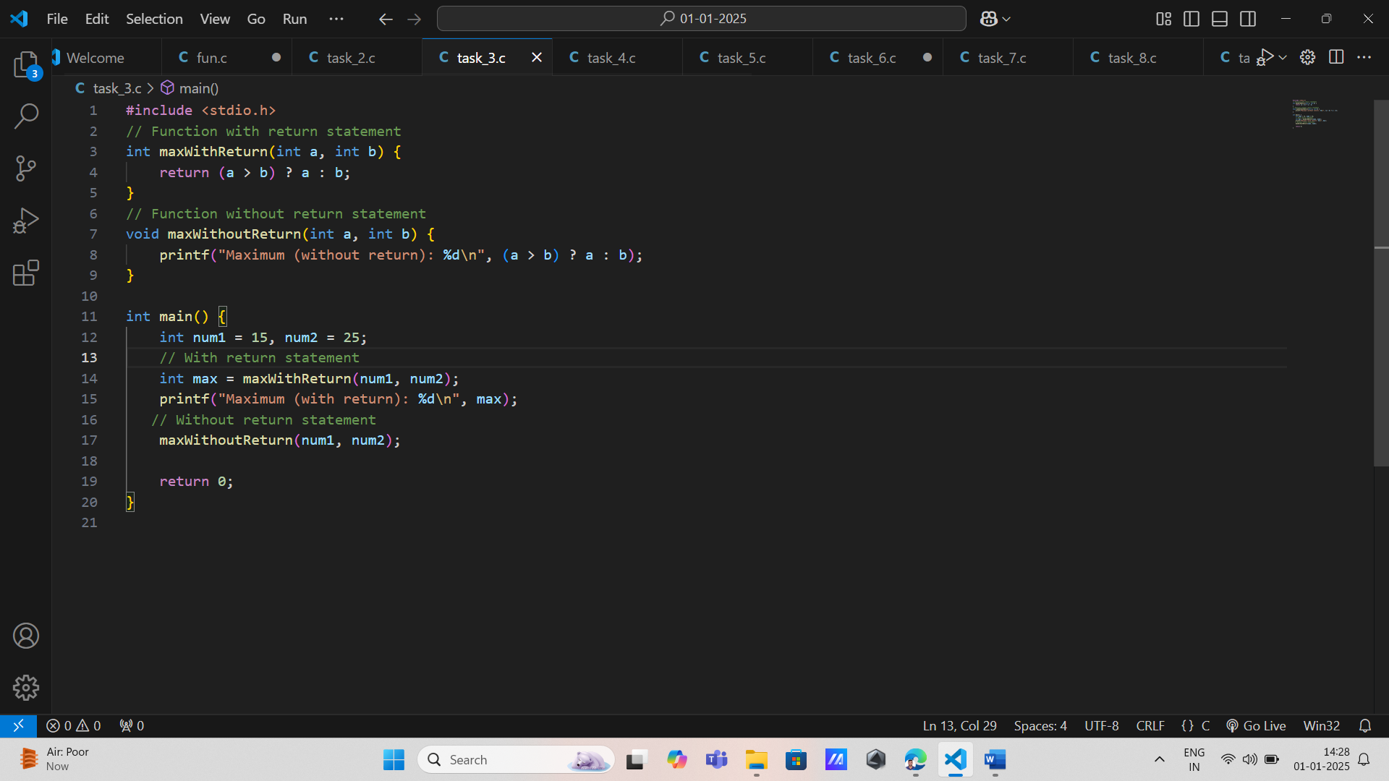

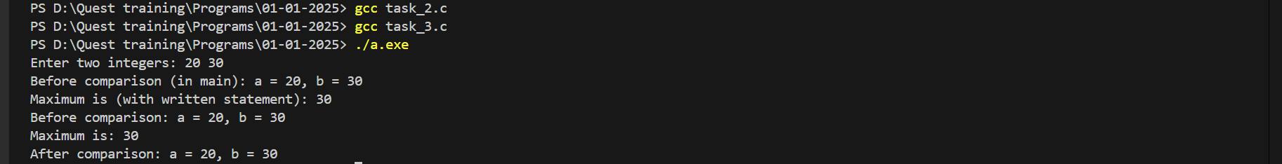

1. **Factorial Calculation**  
   Create a function to compute the factorial of a given number passed to it. Ensure the original number remains unaltered.

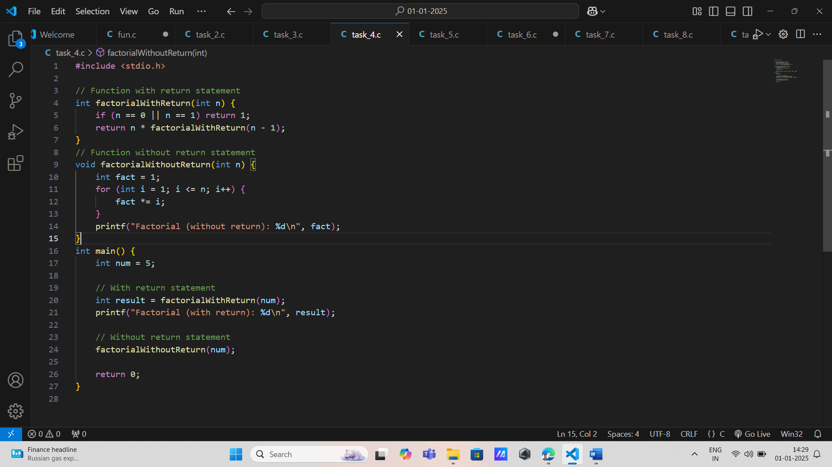

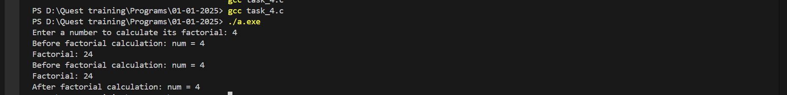

1. **Check Even or Odd**  
   Write a program where a function determines whether a given integer is even or odd. The function should use call by value.

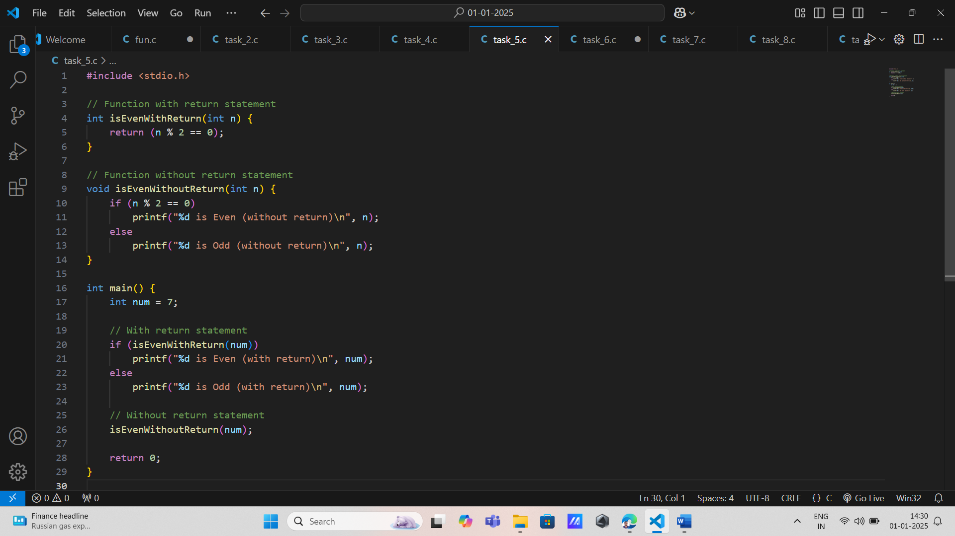

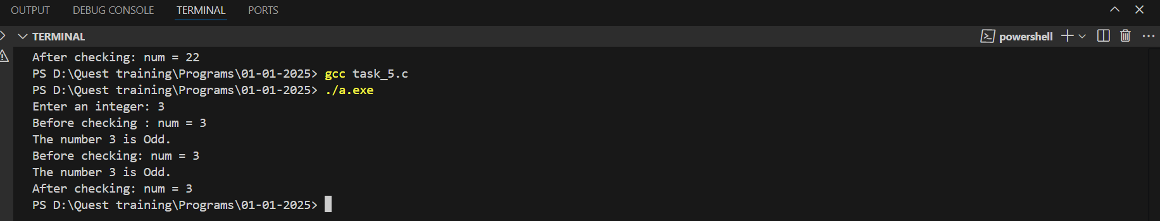

1. **Calculate Simple Interest  
   Write a program that calculates simple interest using a function. Pass principal, rate, and time as arguments and return the computed interest.**

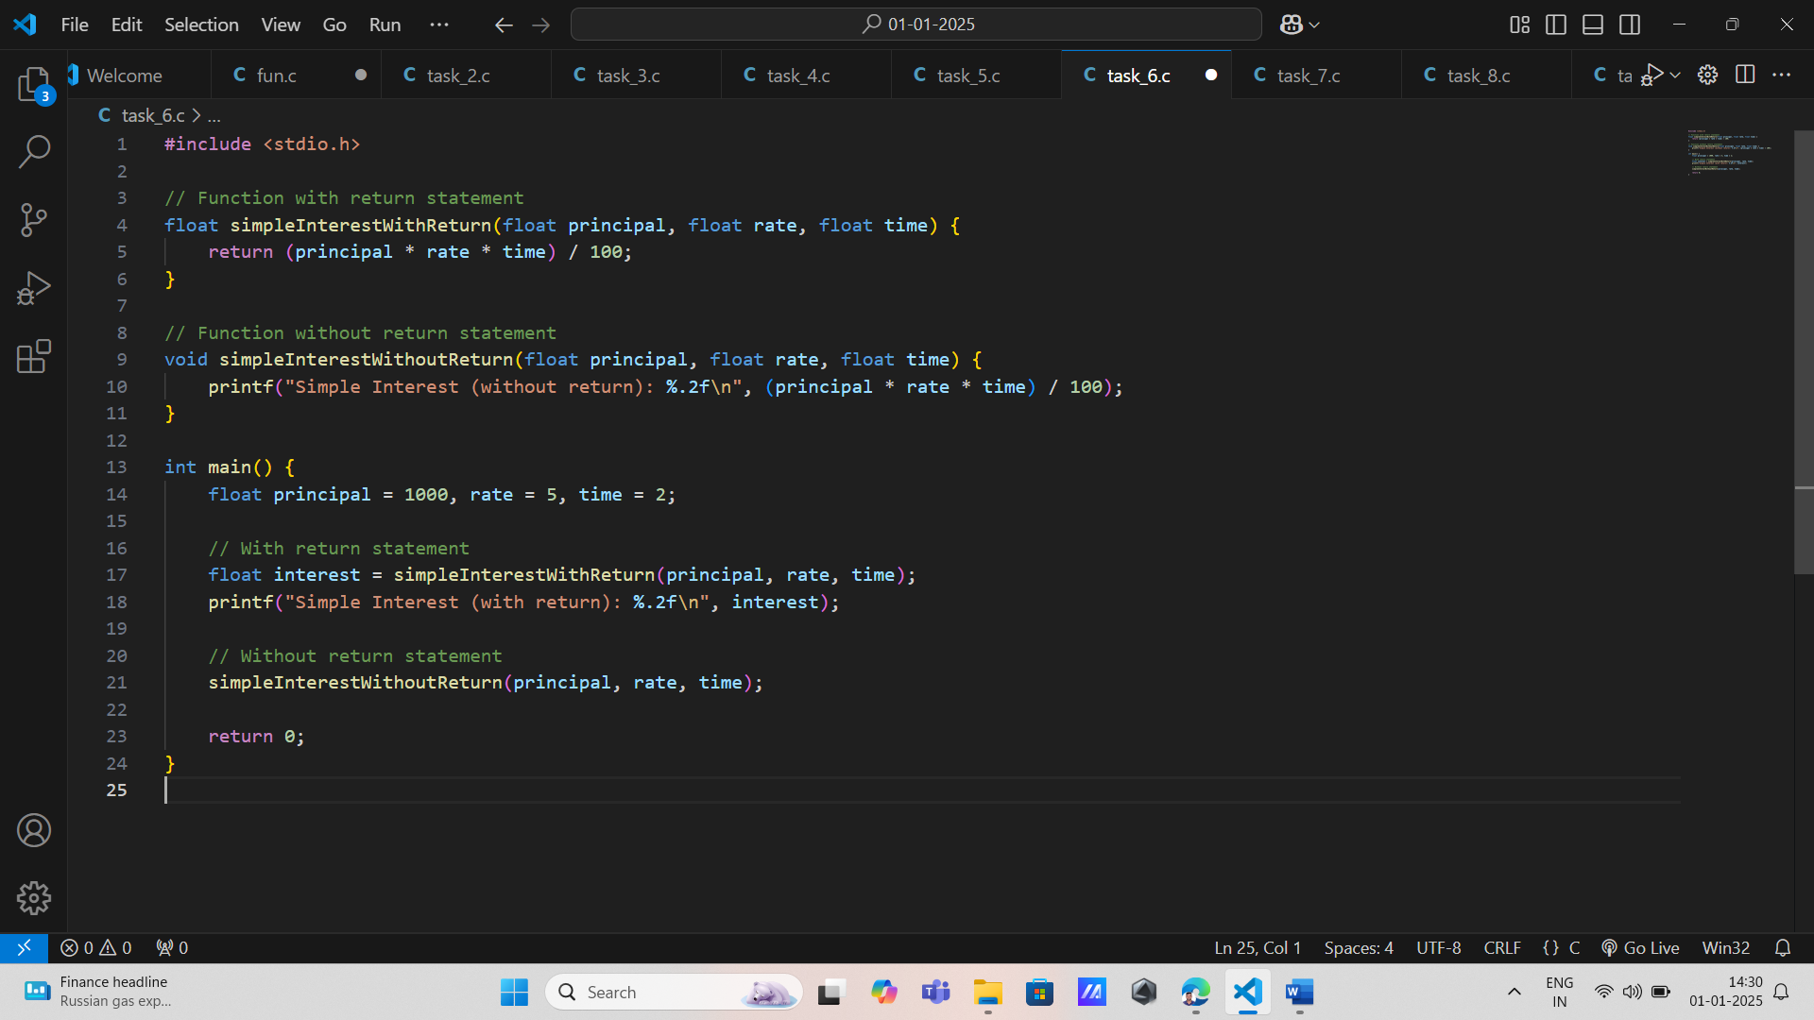

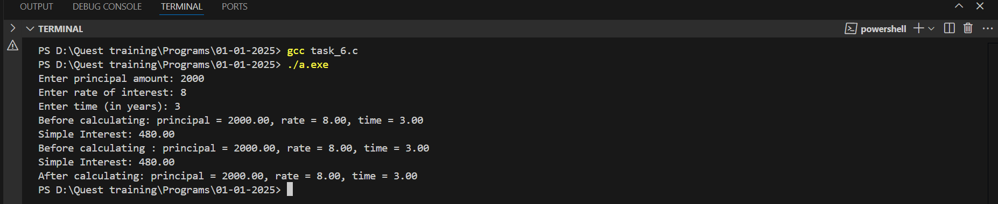

1. **Reverse a Number**  
   Create a function that takes an integer and returns its reverse. Demonstrate how call by value affects the original number.

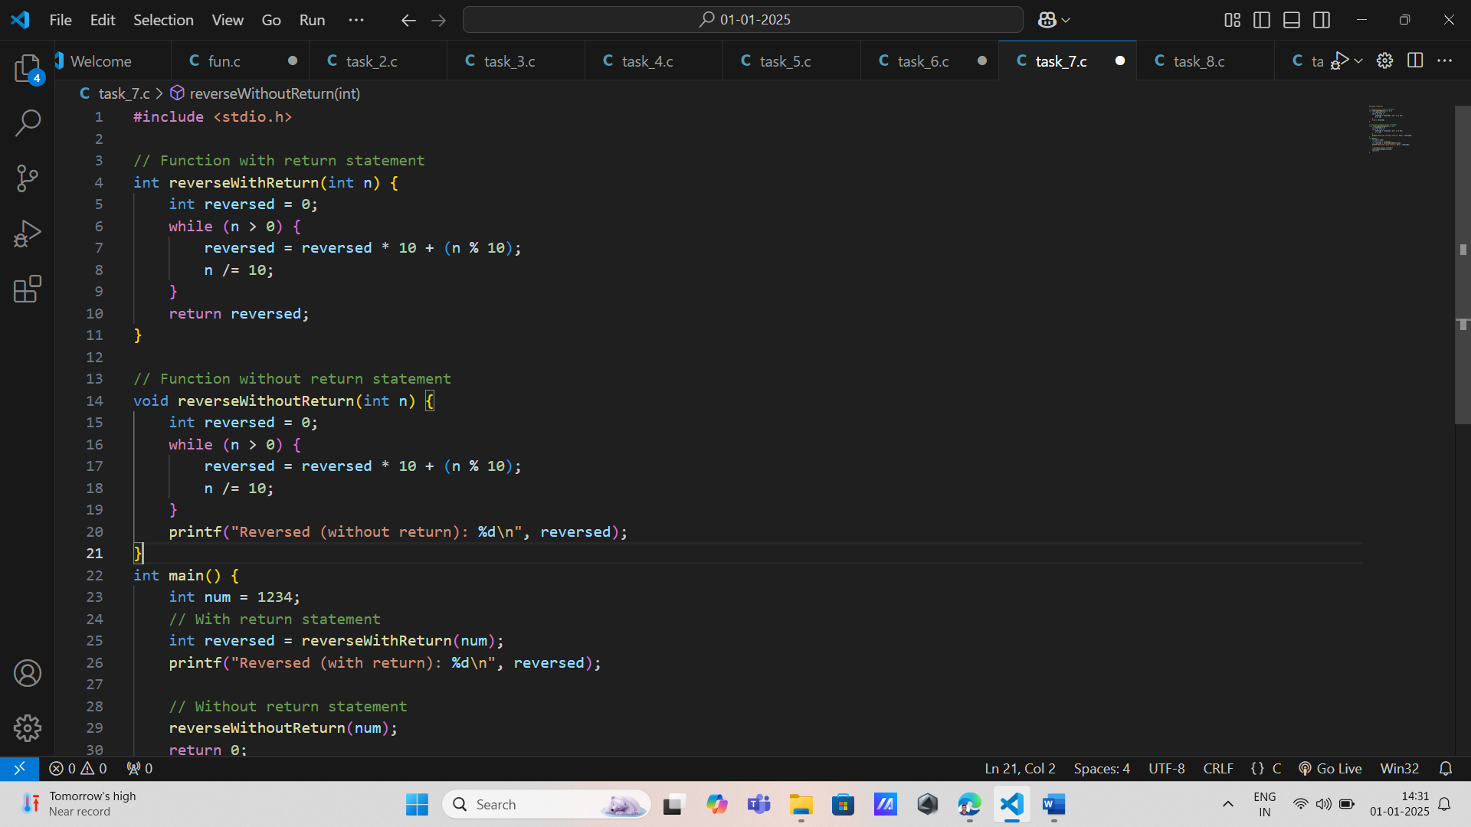

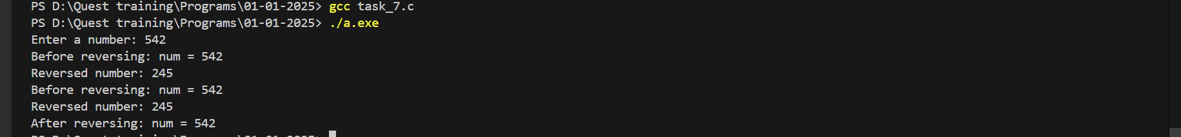

1. **GCD of Two Numbers**  
   Write a function to calculate the greatest common divisor (GCD) of two numbers passed by value.

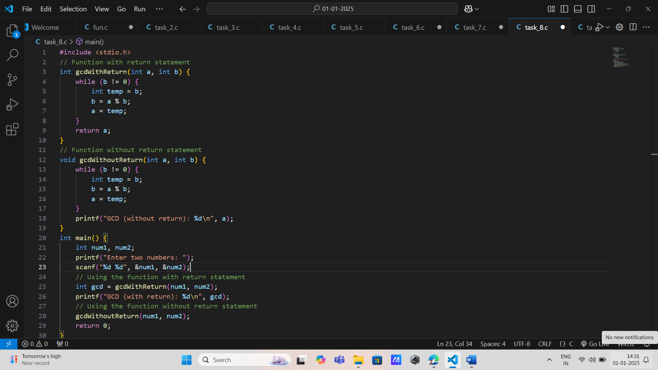

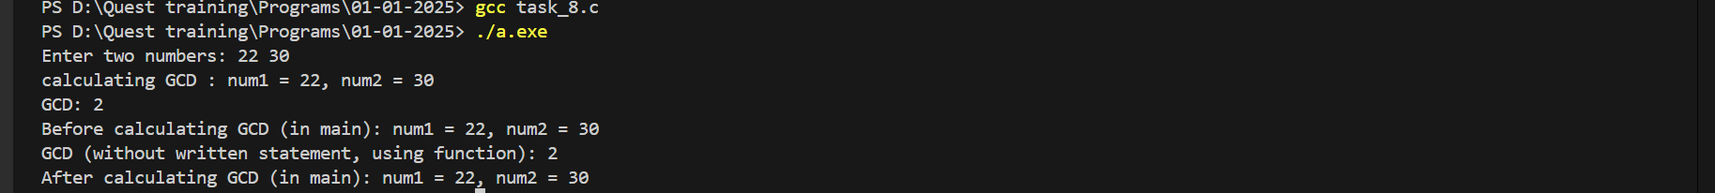

1. **Sum of Digits**  
   Implement a function that computes the sum of the digits of a number passed as an argument.

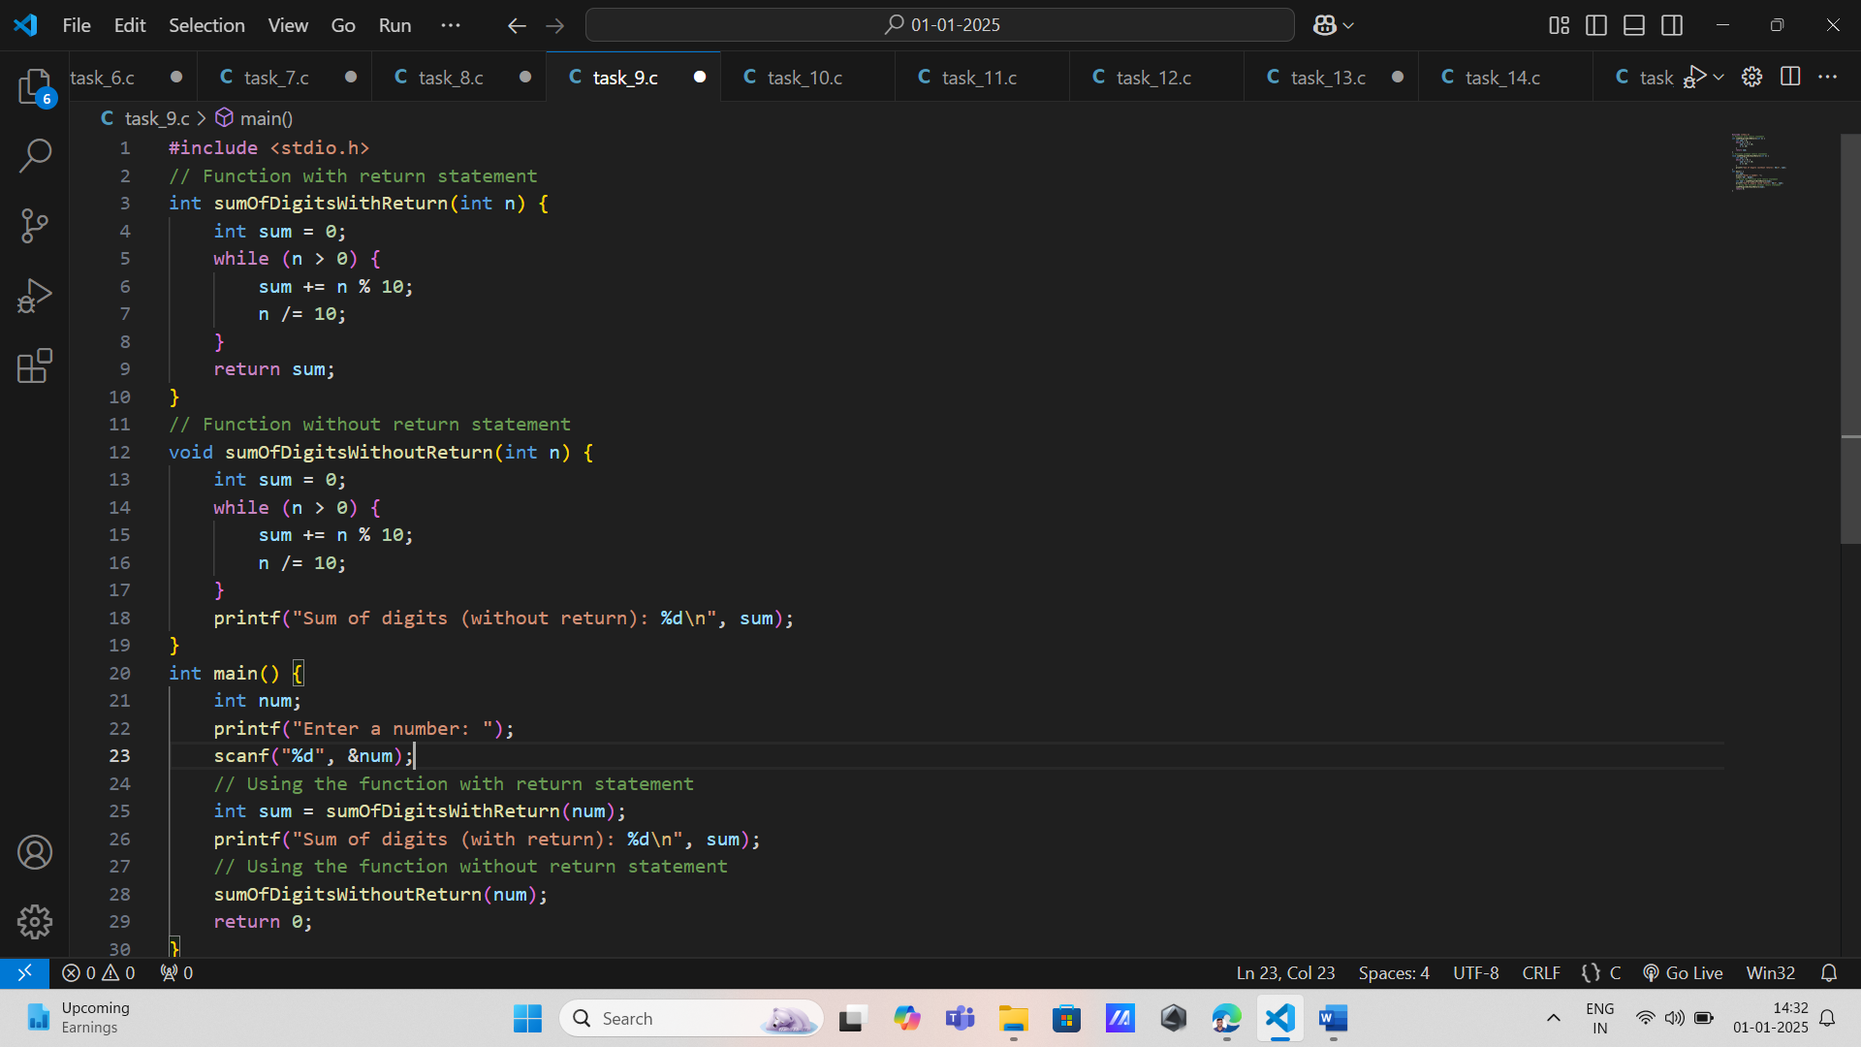

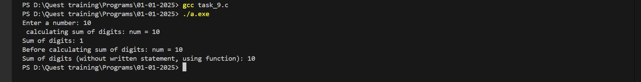

1. **Prime Number Check**  
   Write a program where a function checks if a given number is prime. Pass the number as an argument by value.

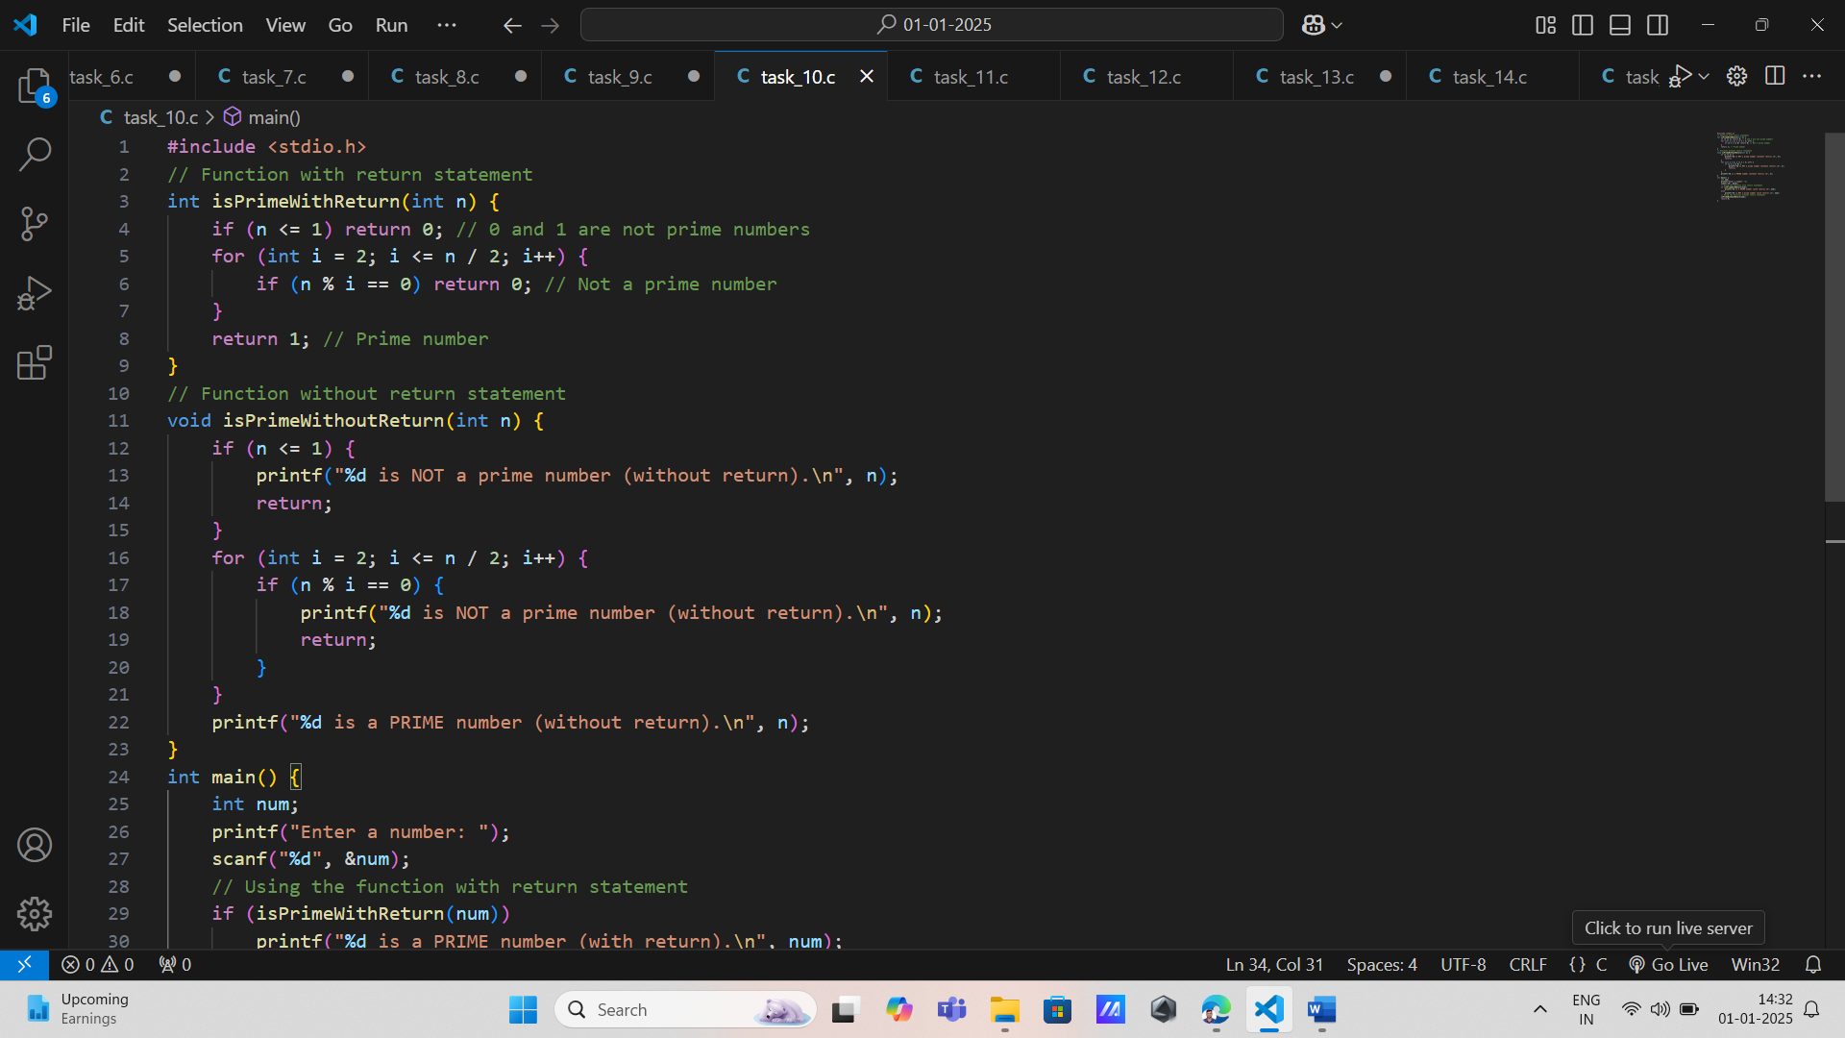

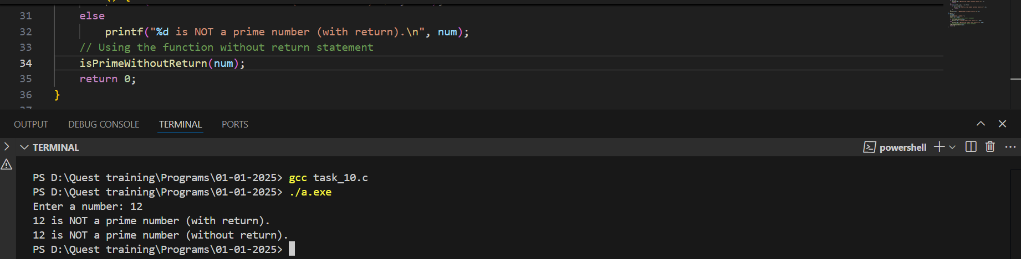

1. **Fibonacci Sequence Check**  
   Create a function that checks whether a given number belongs to the Fibonacci sequence. Pass the number by value.

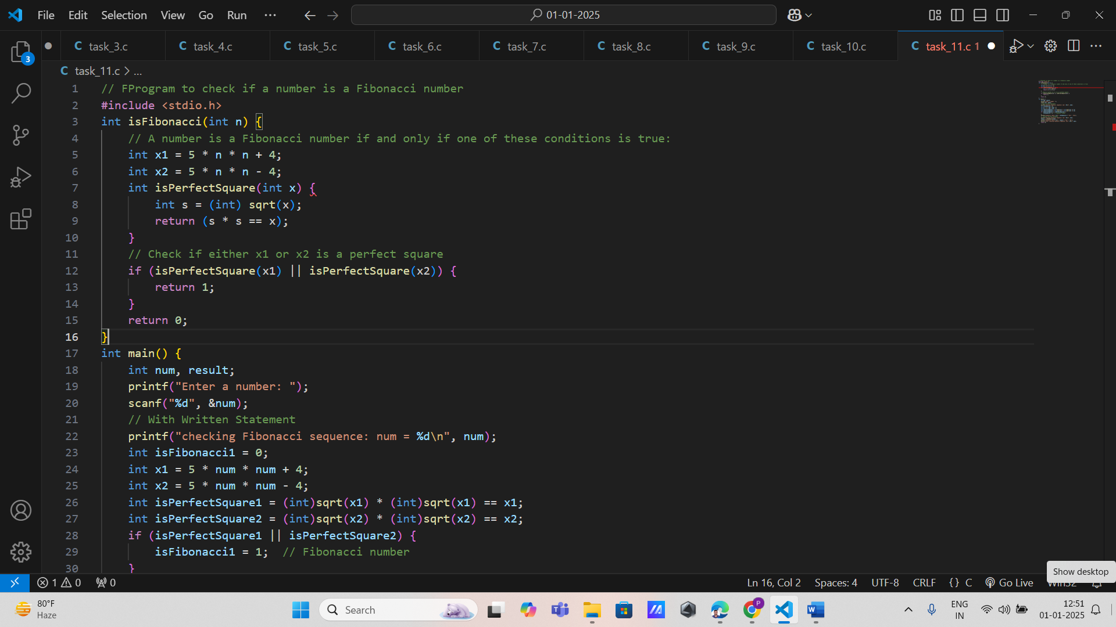

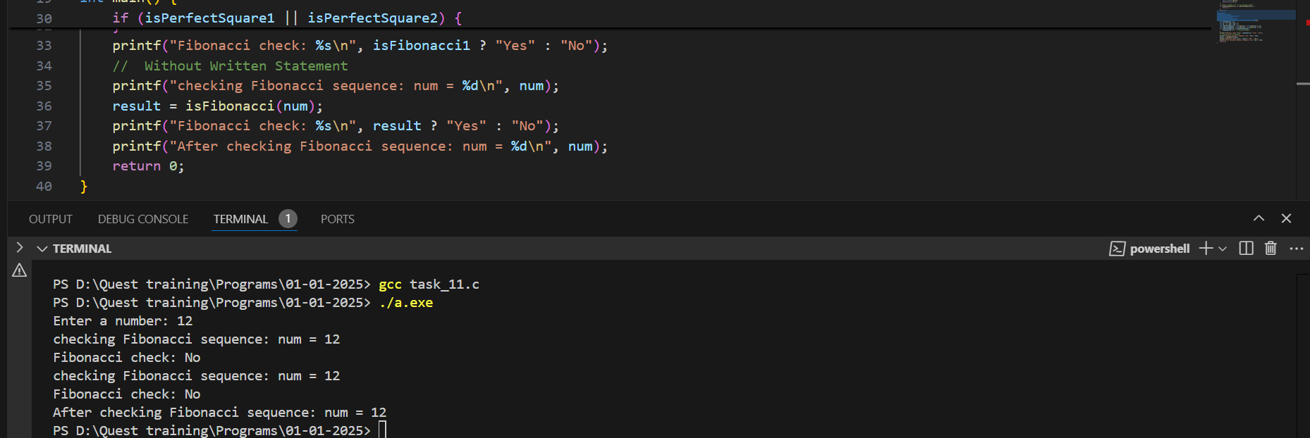

1. **Quadratic Equation Solver**  
   Write a function to calculate the roots of a quadratic equation ax2+bx+c=0ax^2 + bx + c = 0ax2+bx+c=0. Pass the coefficients a,b,a, b,a,b, and ccc as arguments.

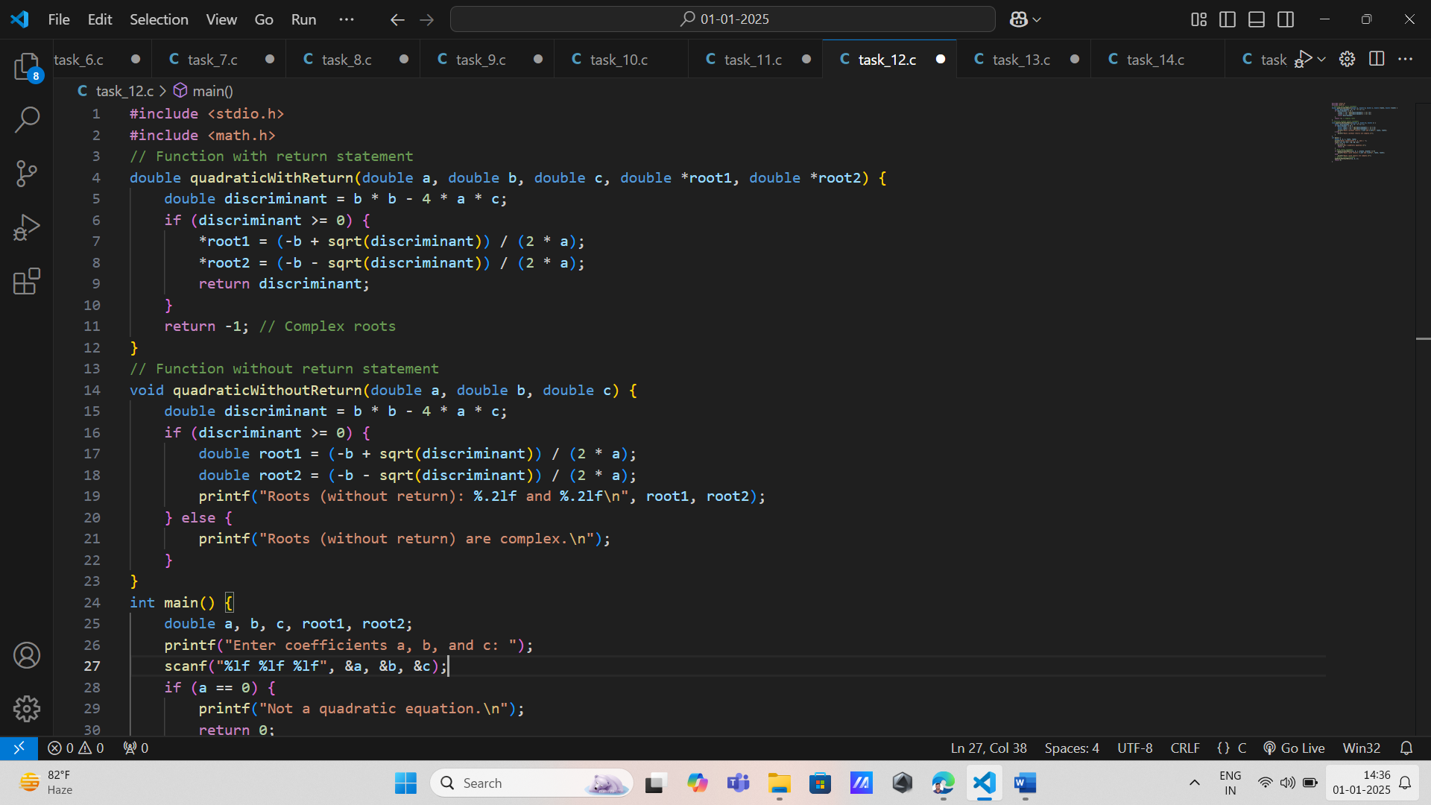

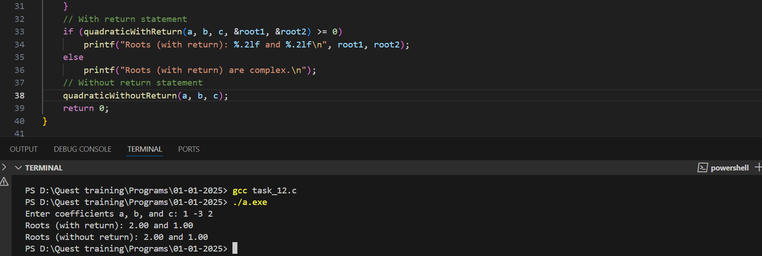

1. **Binary to Decimal Conversion**  
   Implement a function to convert a binary number (passed as an integer) into its decimal equivalent.

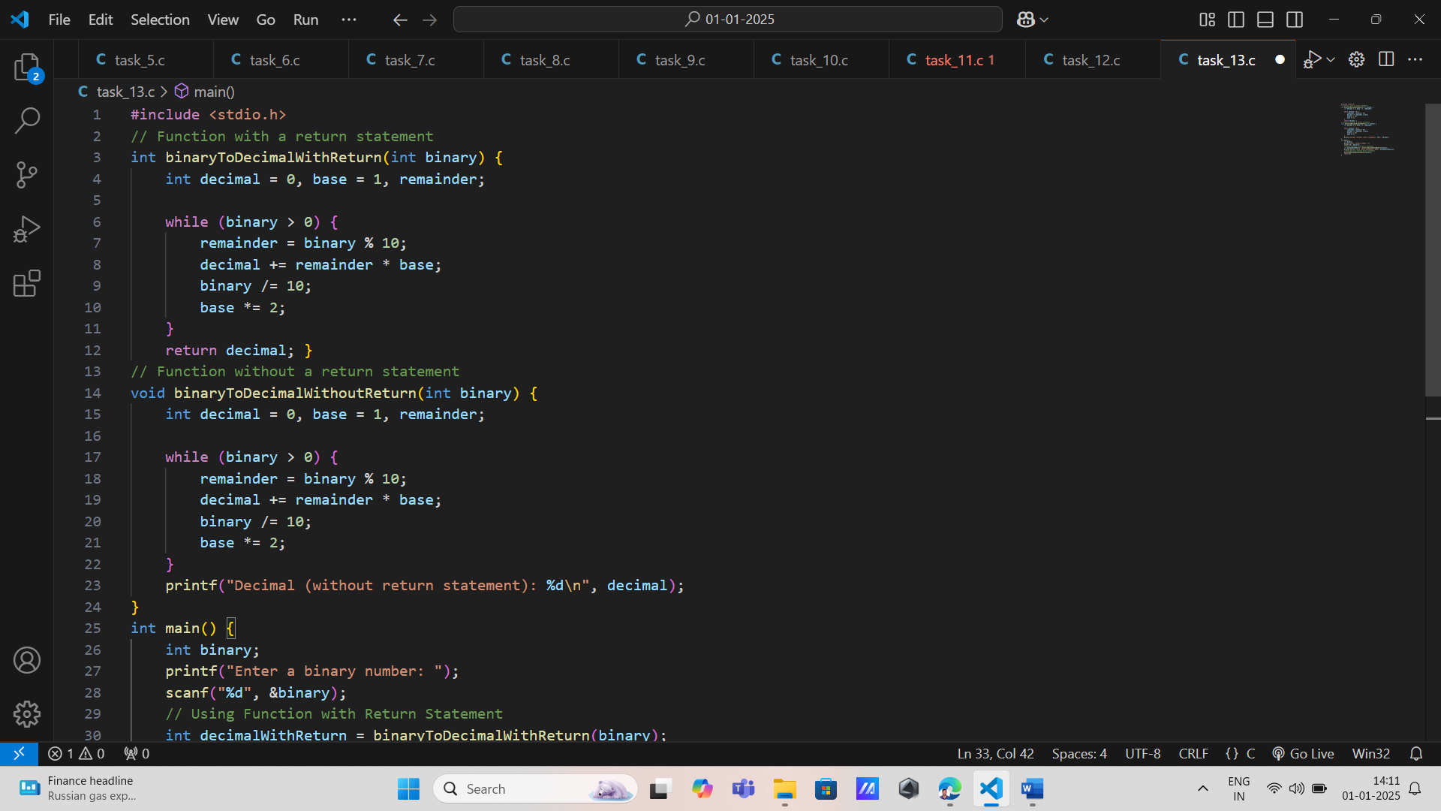

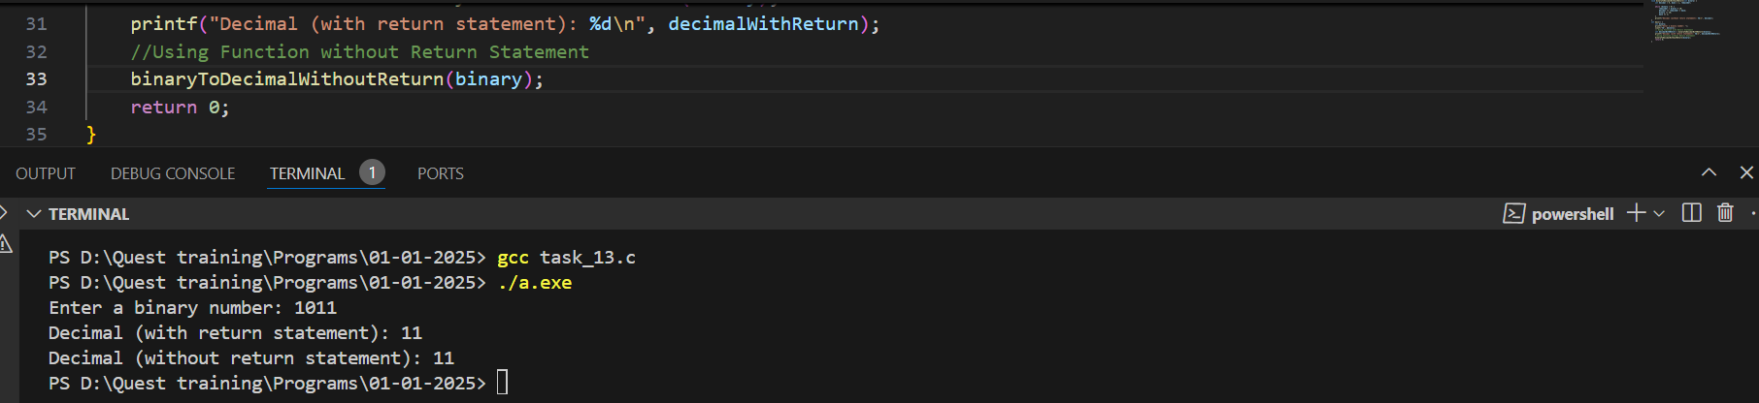

1. **Matrix Trace Calculation**  
   Write a program where a function computes the trace of a 2x2 matrix (sum of its diagonal elements). Pass the matrix elements individually as arguments

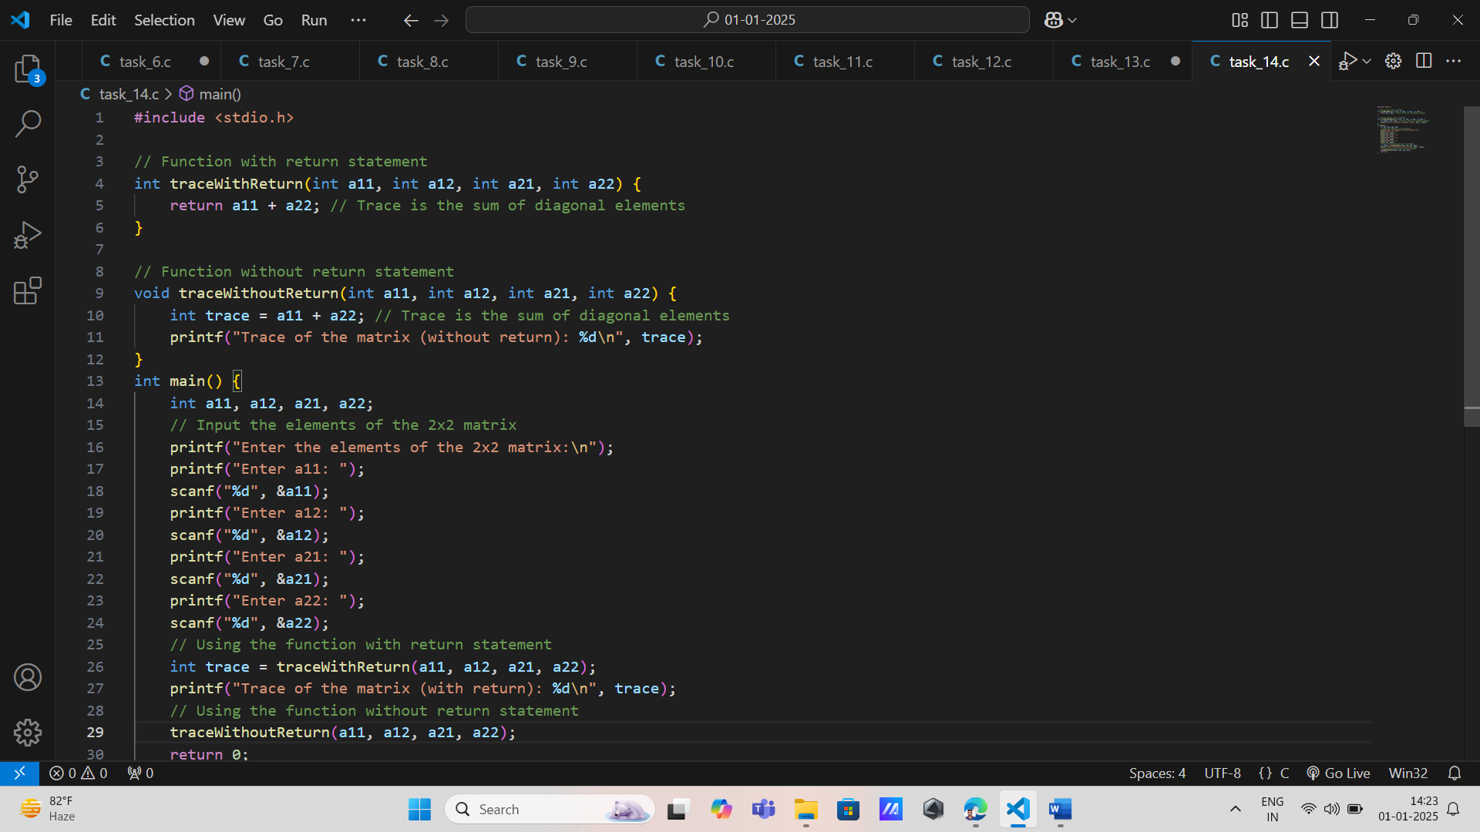

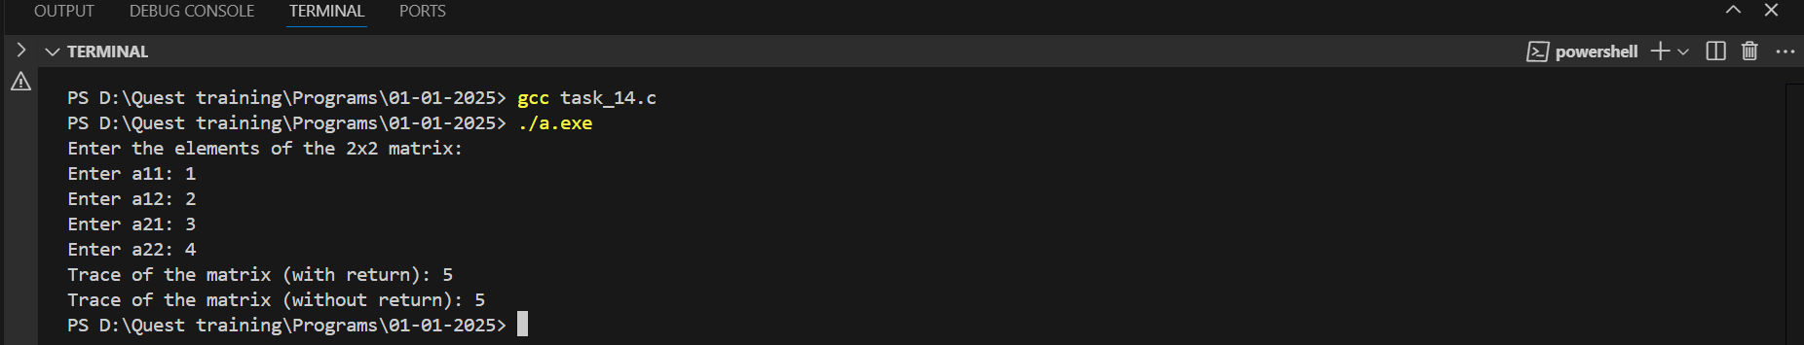

1. **Palindrome Number Check**  
   Create a function that checks whether a given number is a palindrome. Pass the number by value and return the result.

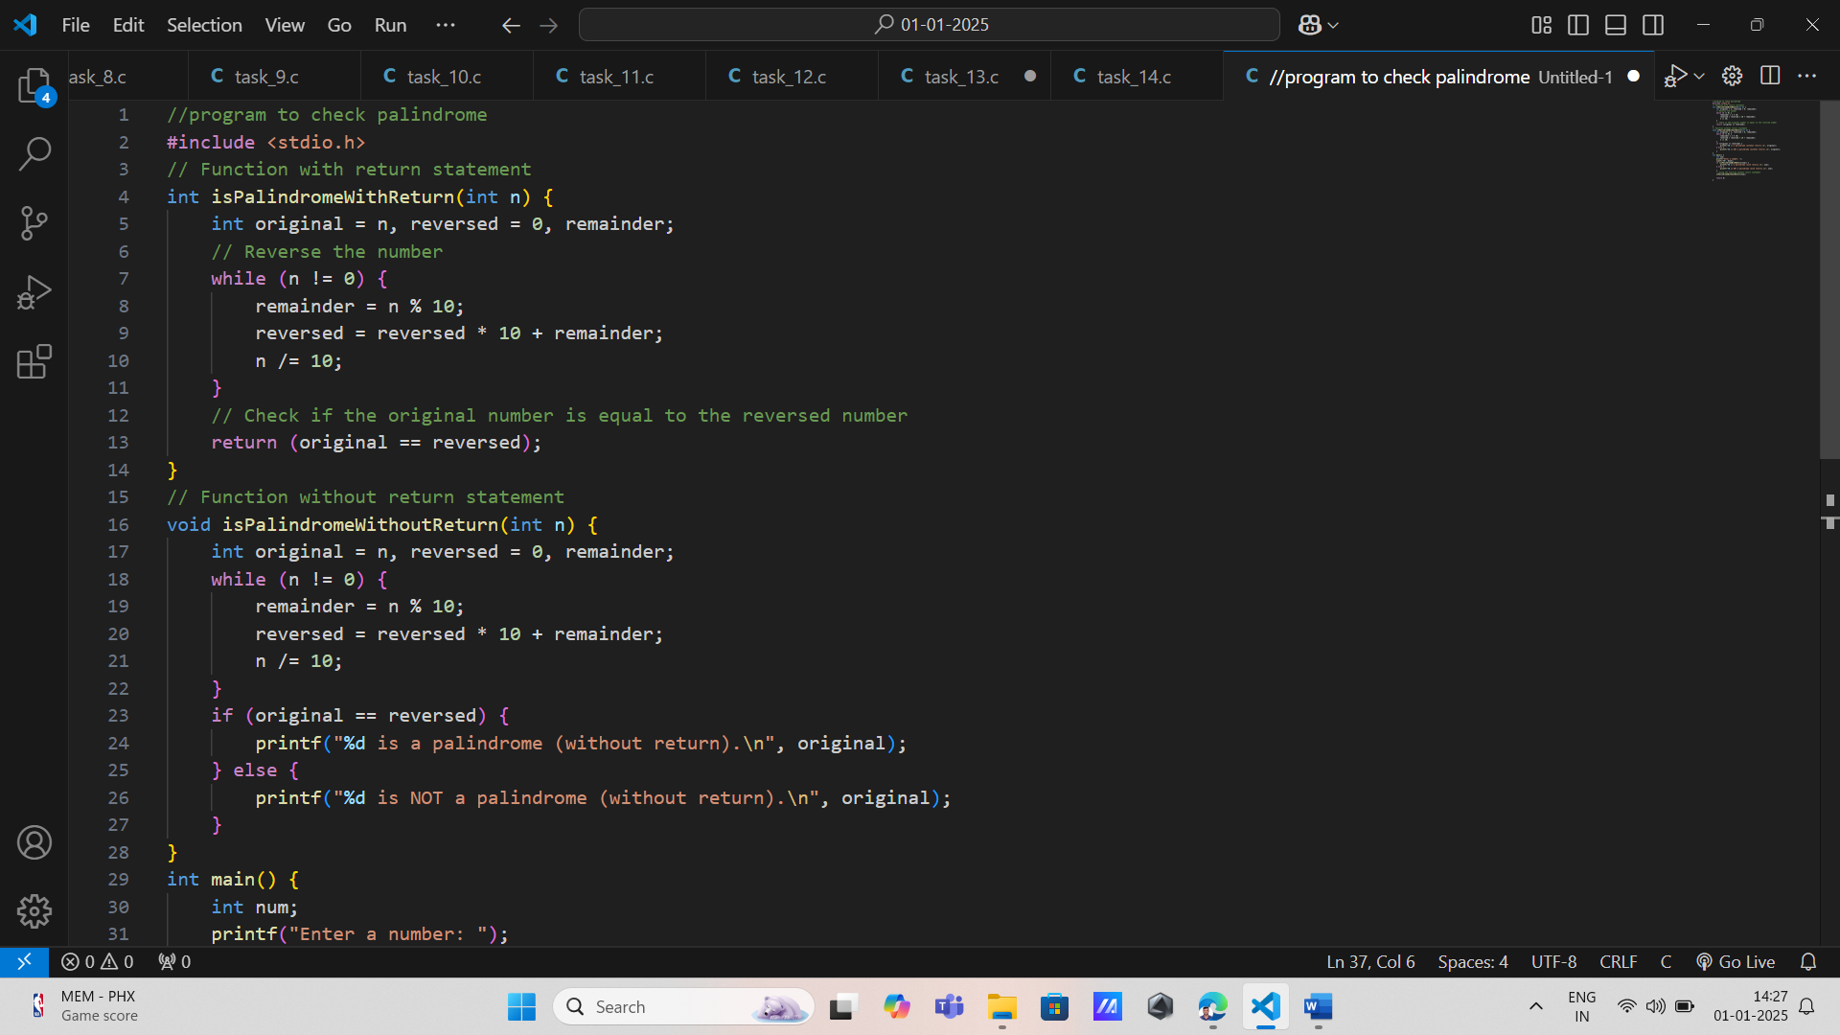

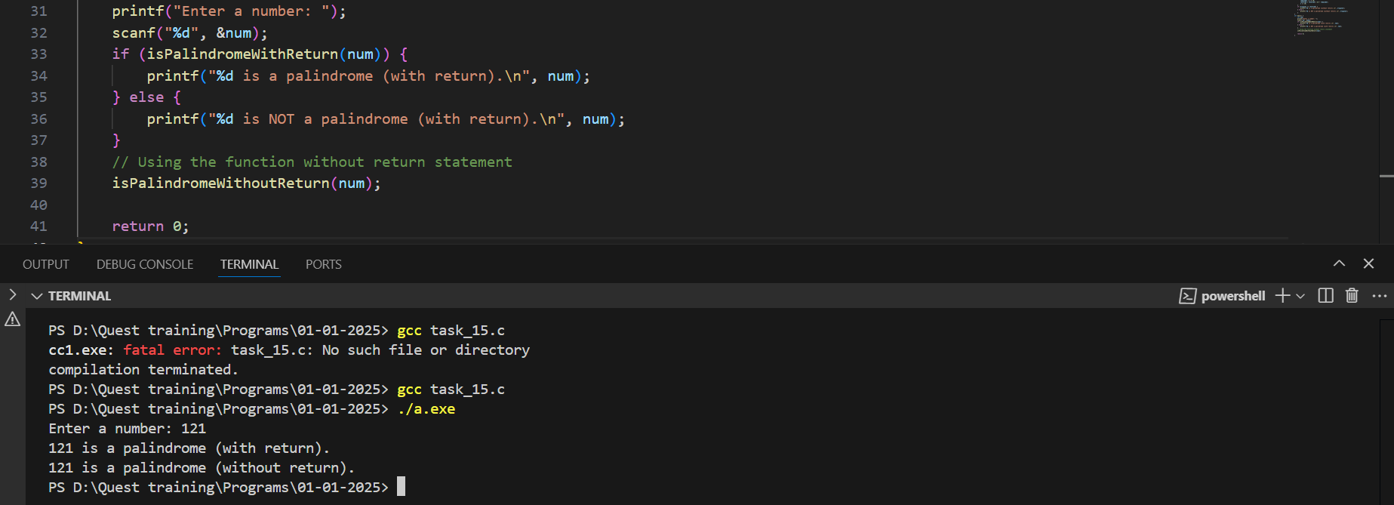

1. **Unit Conversion for Manufacturing Processes**

**Input: A floating-point value representing the measurement and a character indicating the conversion type (e.g., 'C' for cm-to-inches or 'I' for inches-to-cm).**

**\* Output: The converted value.**

**\* Function:float convert_units(float value, char type);**

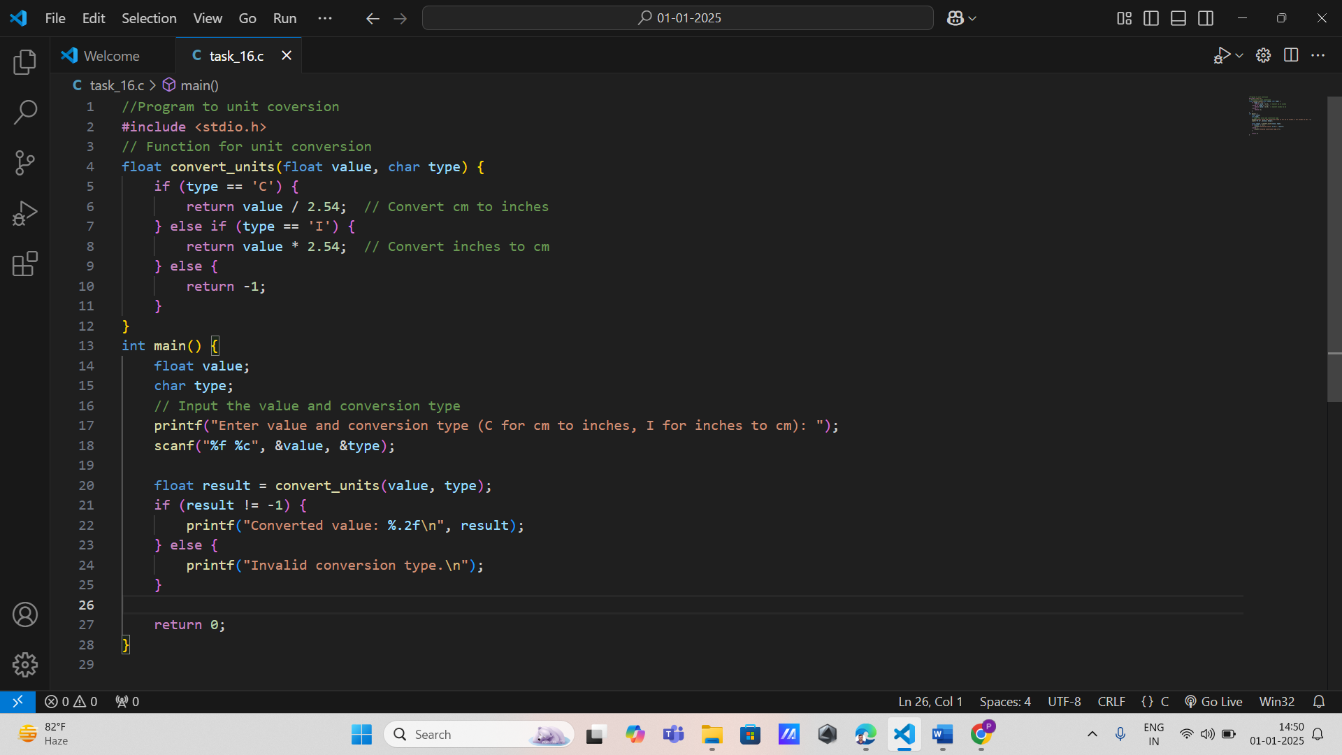

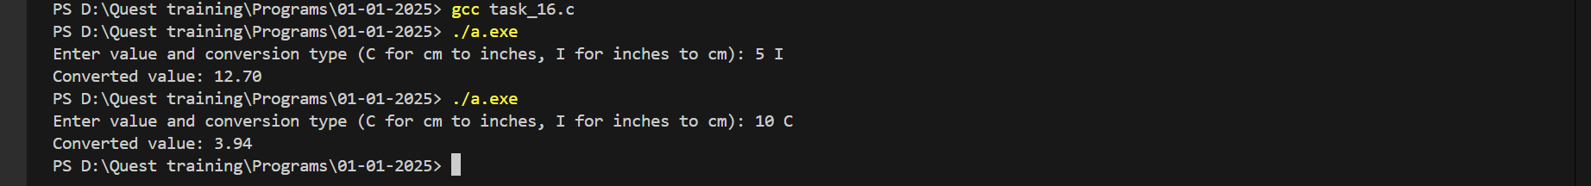

17. **Cutting Material Optimization**

**\* Input: Two integers: the total length of the raw material and the desired length of each piece.**

**\* Output: The maximum number of pieces that can be cut and the leftover material.**

**\* Function: int calculate_cuts(int material_length, int piece_length);**

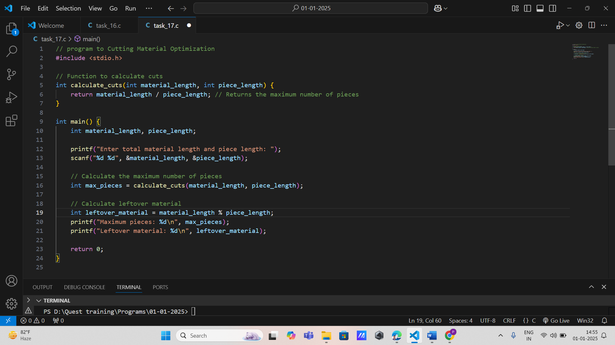

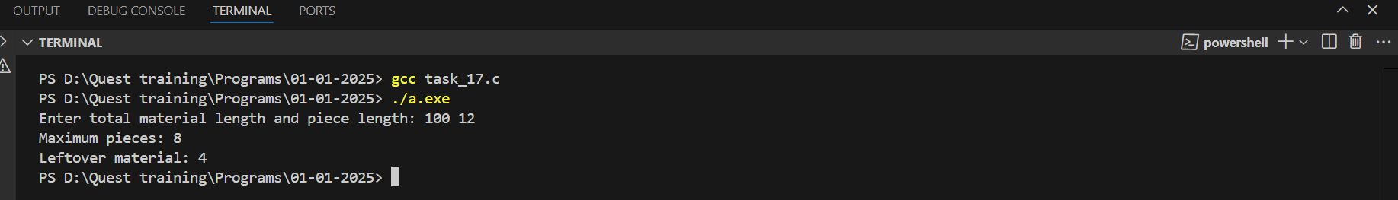

18. **Machine Speed Calculation**

**\* Input: Two floating-point numbers: belt speed (m/s) and pulley diameter (m).**

**\* Output: The RPM of the machine.**

**\* Function: float calculate_rpm(float belt_speed, float pulley_diameter);**

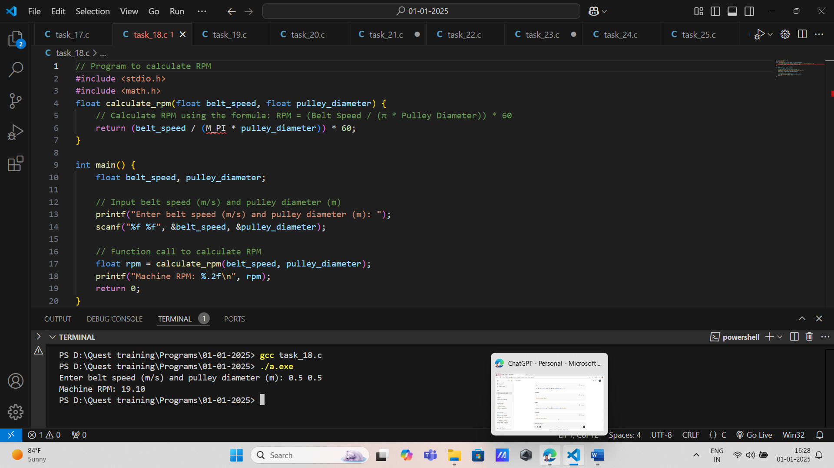

19. Production Rate Estimation

* Input: Two integers: machine speed (units per hour) and efficiency (percentage).

* Output: The effective production rate.

* Function: int calculate_production_rate(int speed, int efficiency);

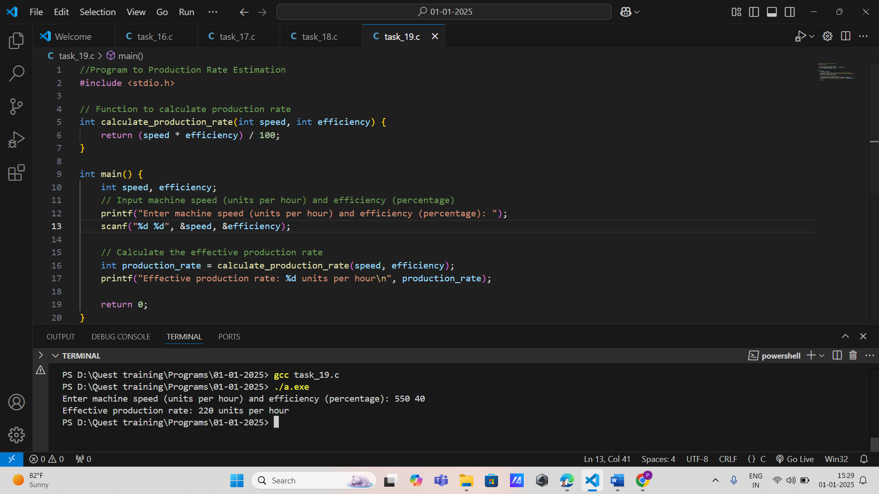

20. Material Wastage Calculation

* Input: Two integers: total material length and leftover material length.

* Output: The amount of material wasted.

* Function: int calculate_wastage(int total_length, int leftover_length);

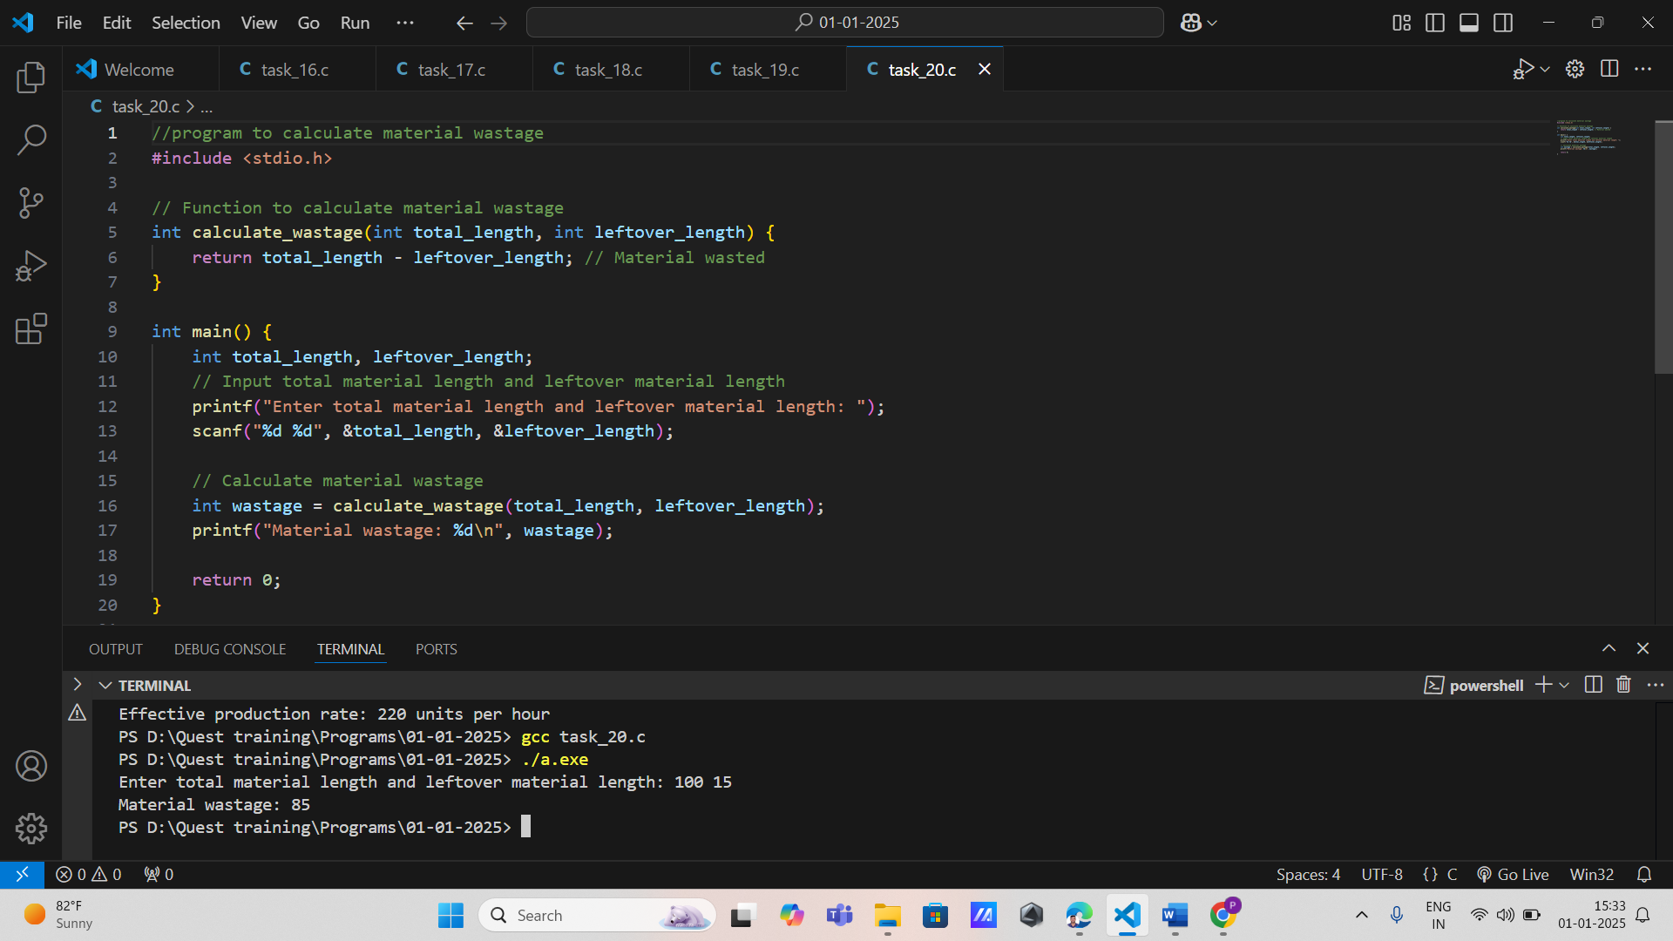

21. Energy Cost Estimation

* Input: Three floating-point numbers: power rating (kW), operating hours, and cost per kWh.

* Output: The total energy cost.

* Function:float calculate_energy_cost(float power_rating, float hours, float cost_per_kwh);

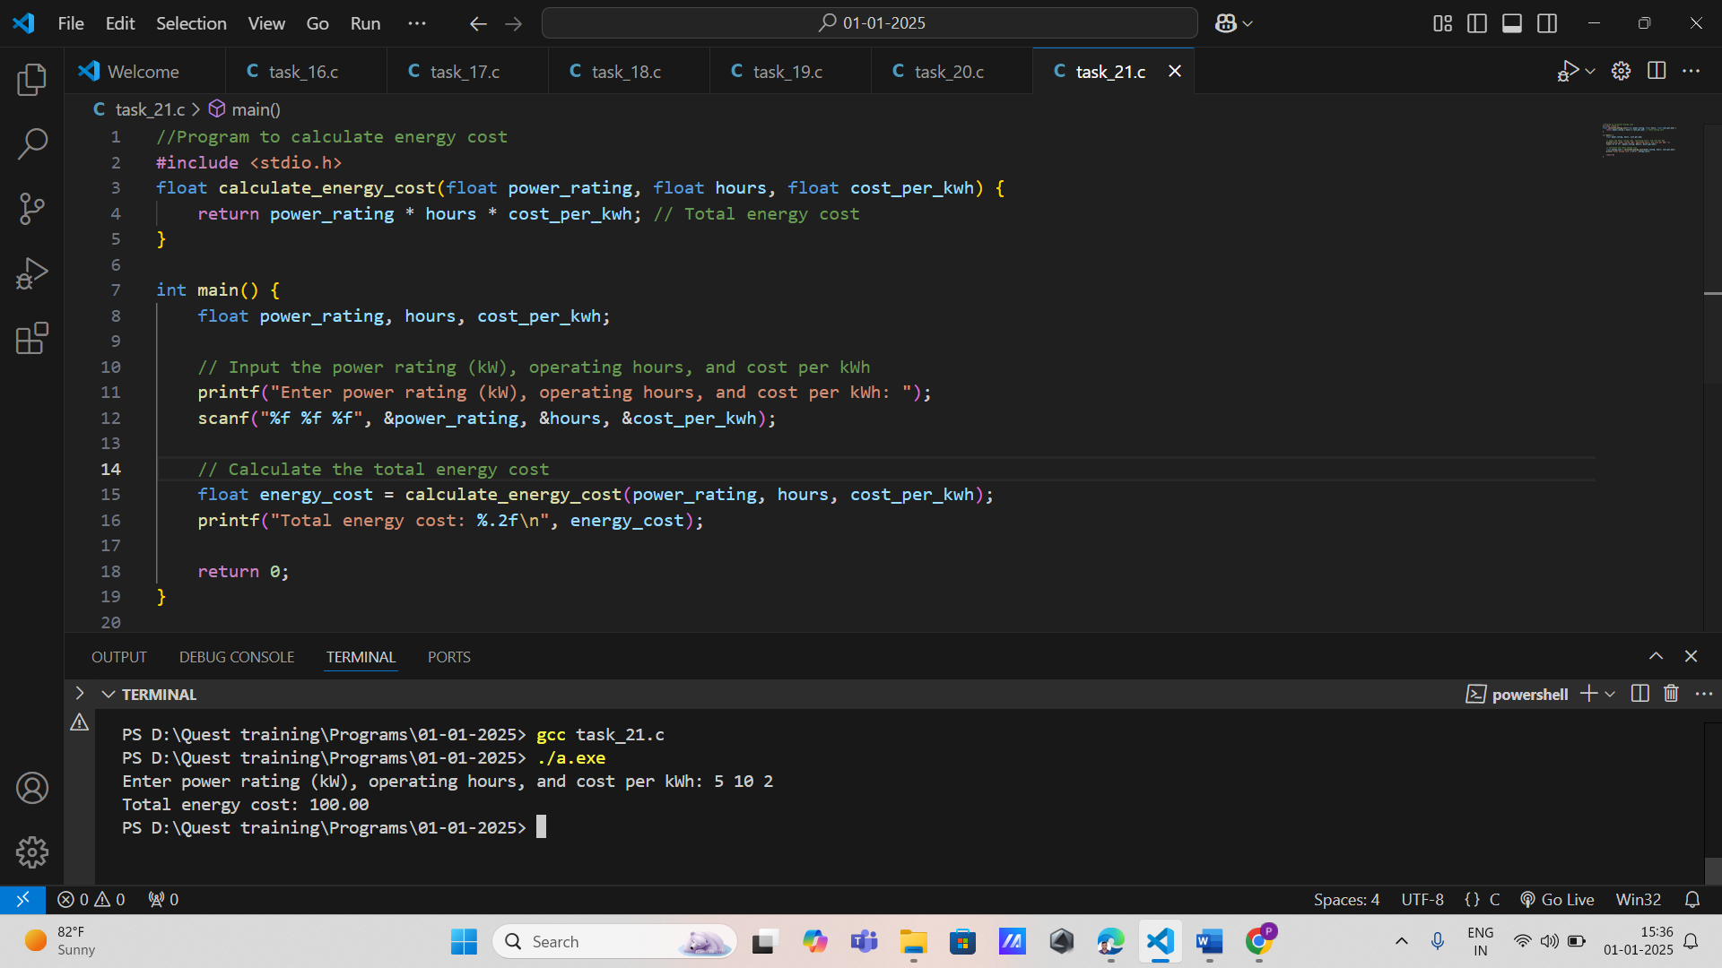

22. Heat Generation in Machines

* Input: Two floating-point numbers: power usage (Watts) and efficiency (%).

* Output: Heat generated (Joules).

* Function: float calculate_heat(float power_usage, float efficiency);

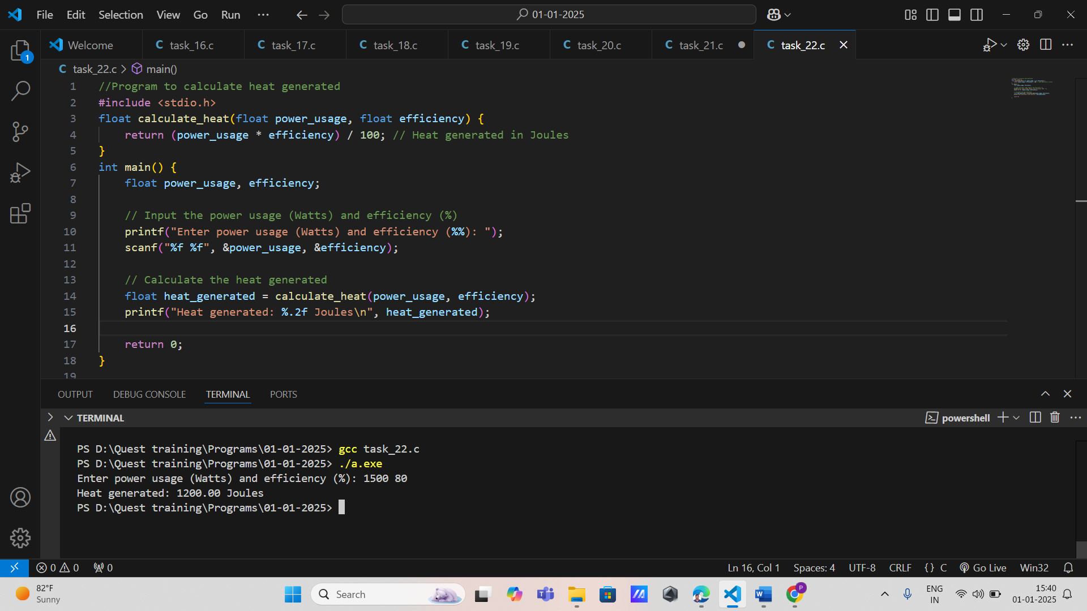

23. Tool Wear Rate Calculation Input: A floating-point number for operating time (hours) and an integer for material type (e.g., 1 for metal, 2 for plastic).

* Output: Wear rate (percentage).

* Function:float calculate_wear_rate(float time, int material_type);

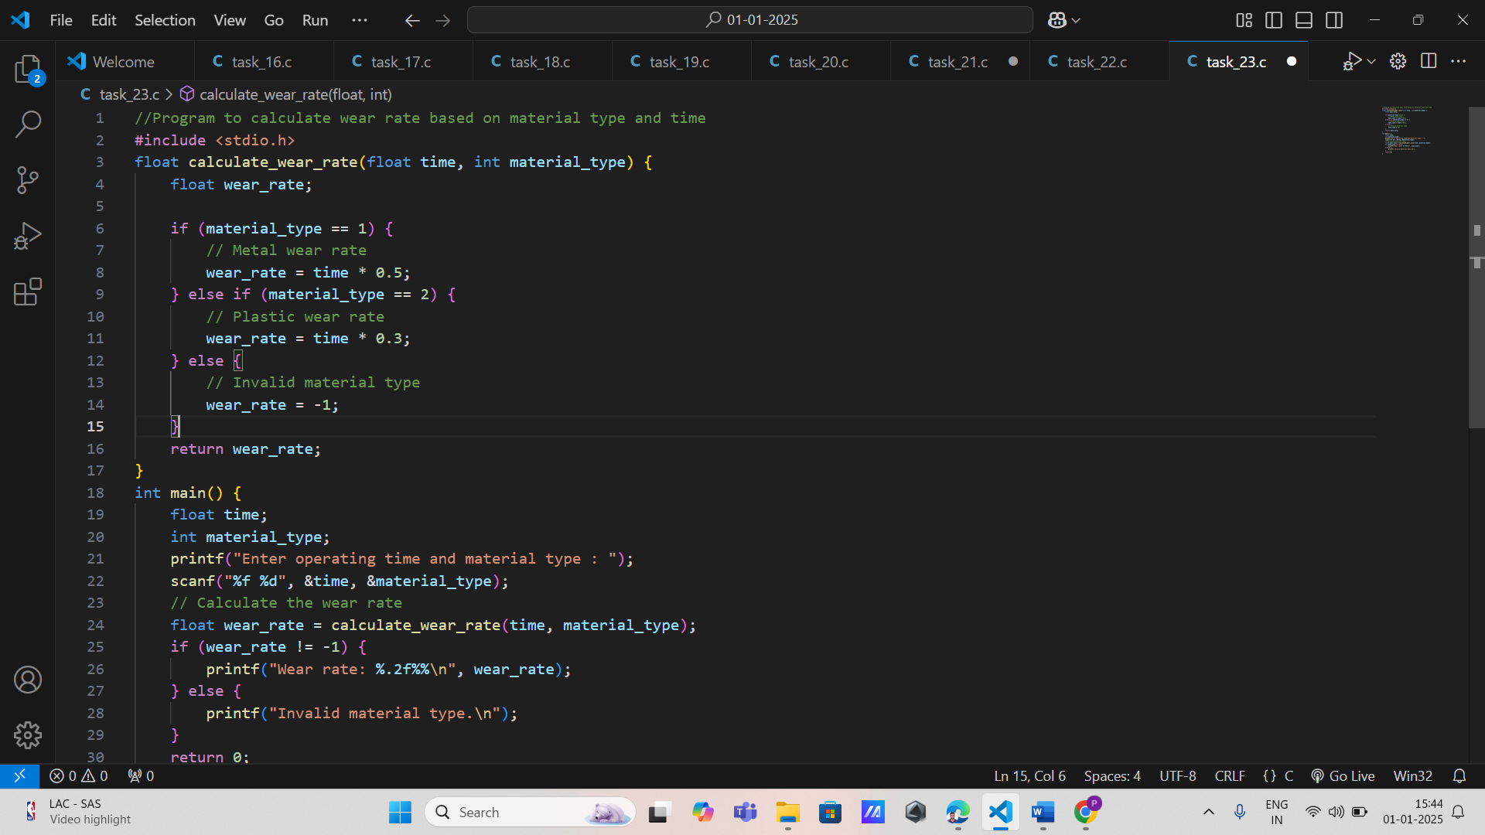

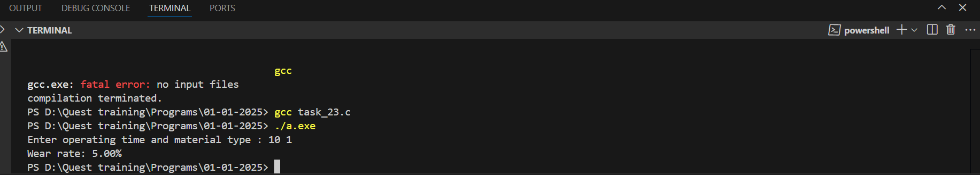

24. Inventory ManagementInput: Two integers: consumption rate (units/day) and lead time (days).

* Output: Reorder quantity (units).

* Function: int calculate_reorder_quantity(int consumption_rate, int lead_time);

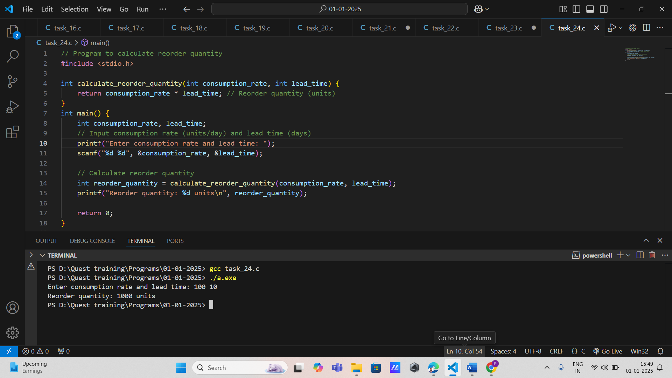

25. Quality Control: Defective Rate Analysis

* Input: Two integers: number of defective items and total batch size.

* Output: Defective rate (percentage).

* Function:float calculate_defective_rate(int defective_items, int batch_size);

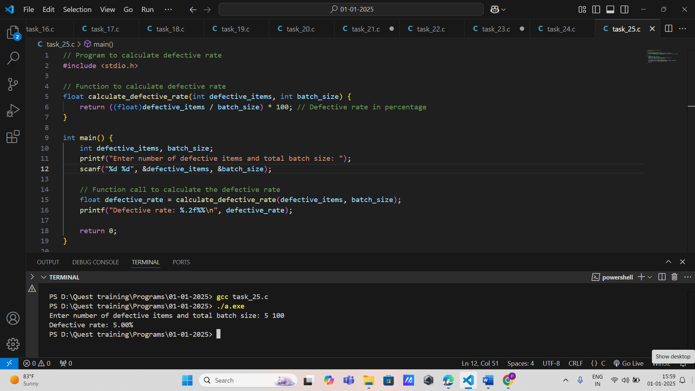

26. Assembly Line Efficiency Input: Two integers: output rate (units/hour) and downtime (minutes).

* Output: Efficiency (percentage).

* Function:float calculate_efficiency(int output_rate, int downtime);

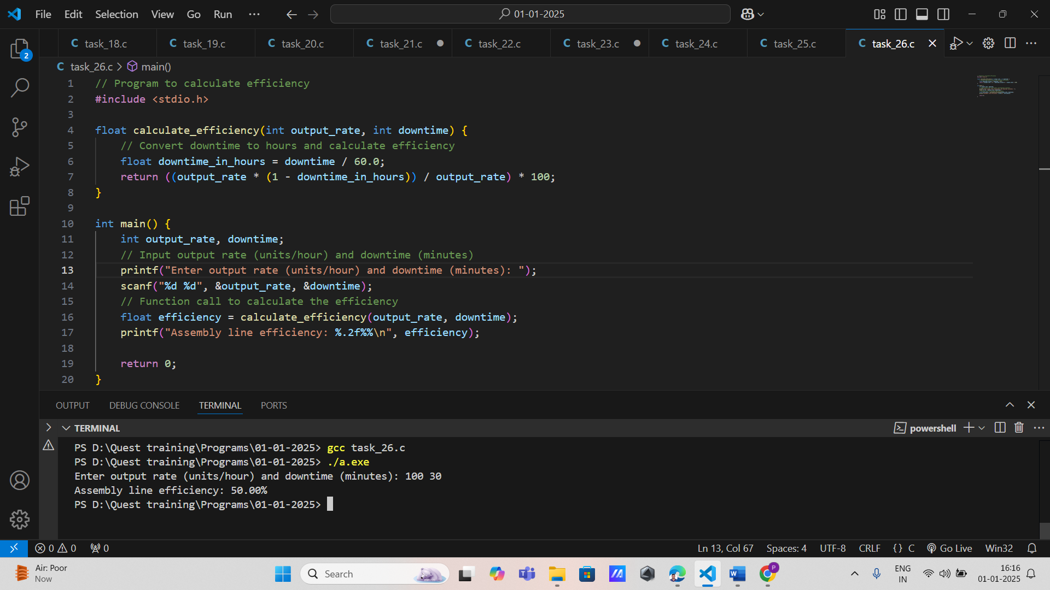

27. Paint Coverage Estimation: Input: Two floating-point numbers: surface area (m²) and paint coverage per liter (m²/liter).

* Output: Required paint (liters).

* Function: float calculate_paint(float area, float coverage);

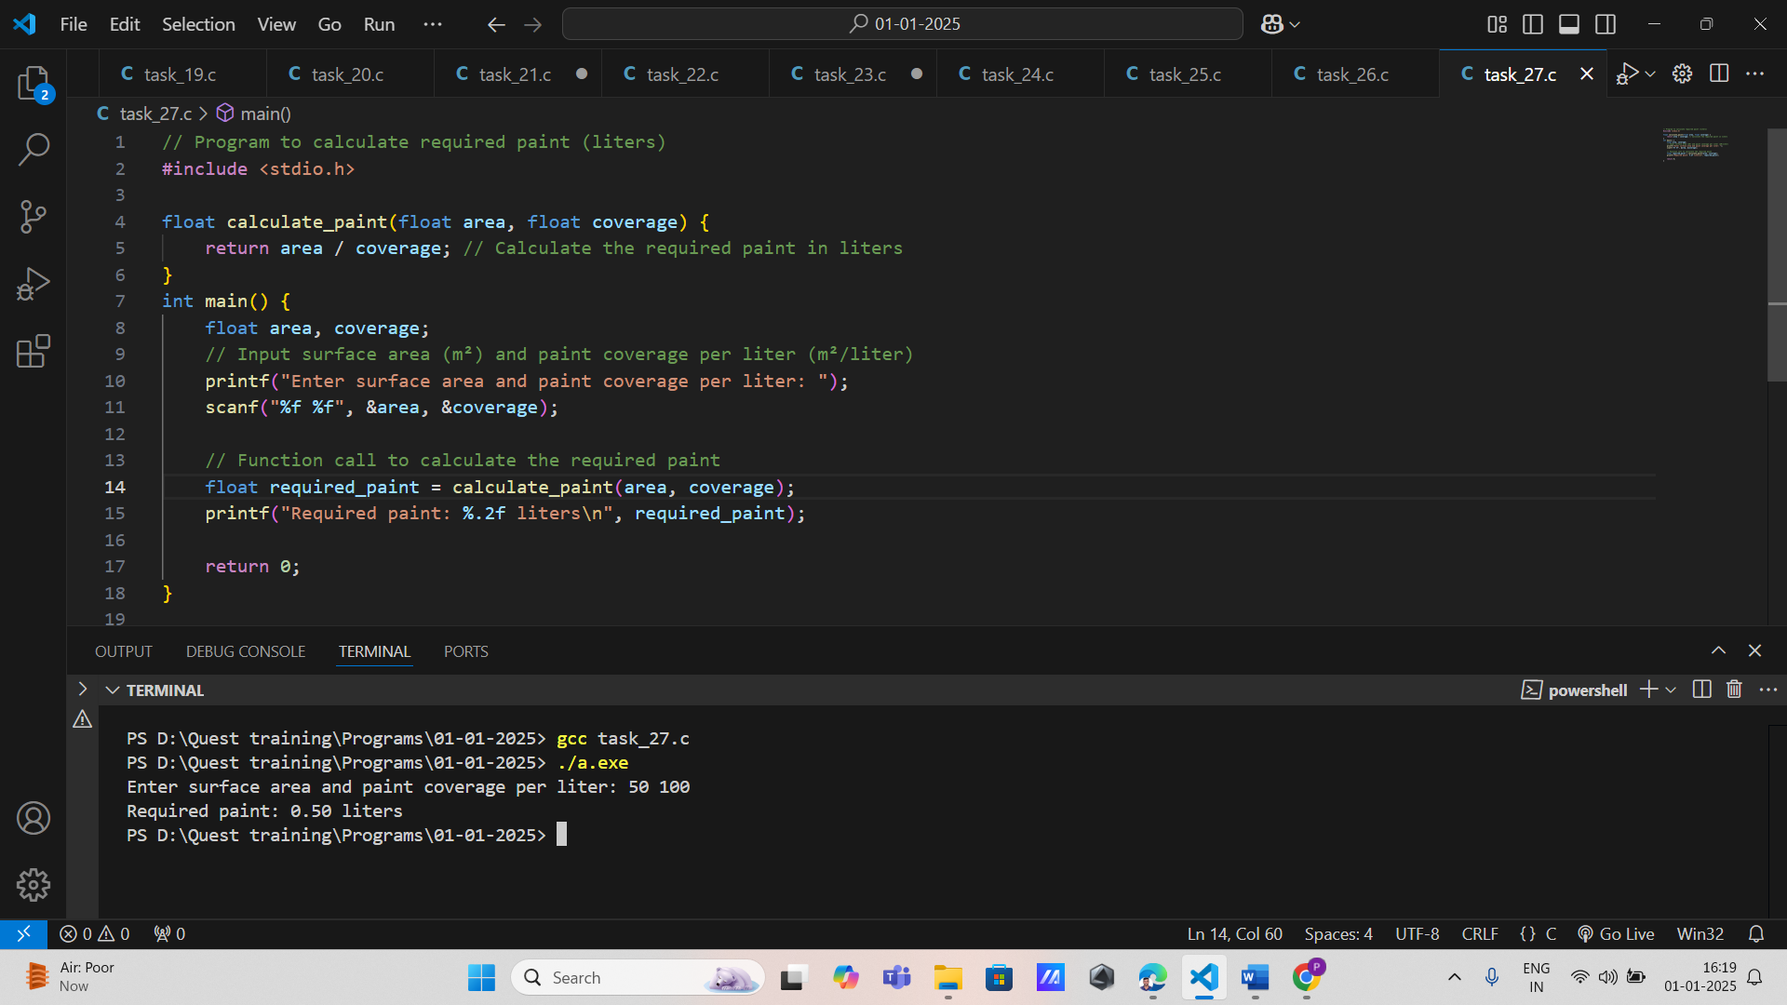

28. Machine Maintenance Schedule: Input: Two integers: current usage (hours) and maintenance interval (hours).

* Output: Hours remaining for maintenance.

* Function: int calculate_maintenance_schedule(int current_usage, int interval);

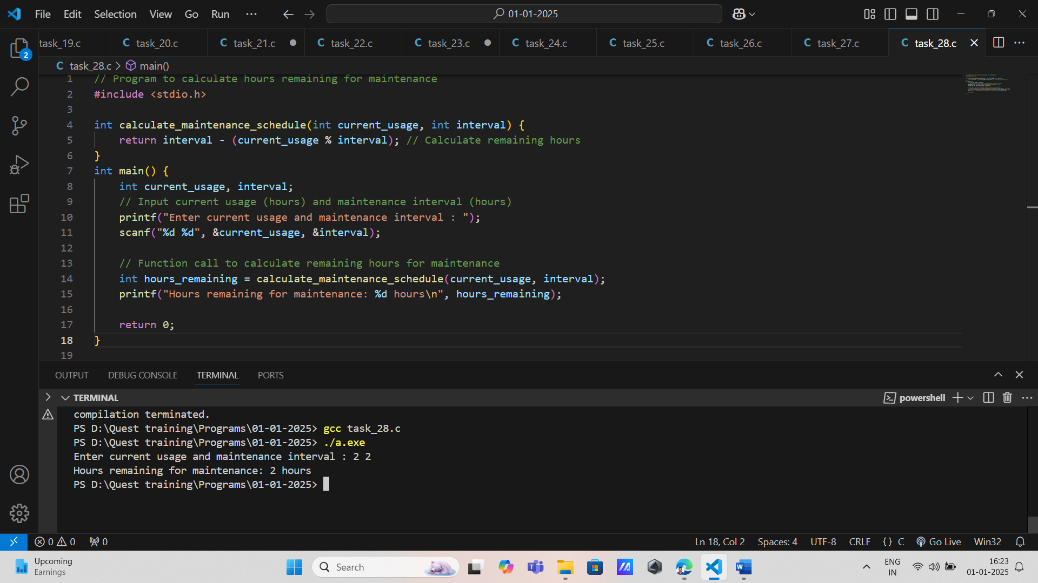

29. 14. Cycle Time Optimization: Input: Two integers: machine speed (units/hour) and number of operations per cycle.

* Output: Optimal cycle time (seconds).

* Function: float calculate_cycle_time(int speed, int operations);

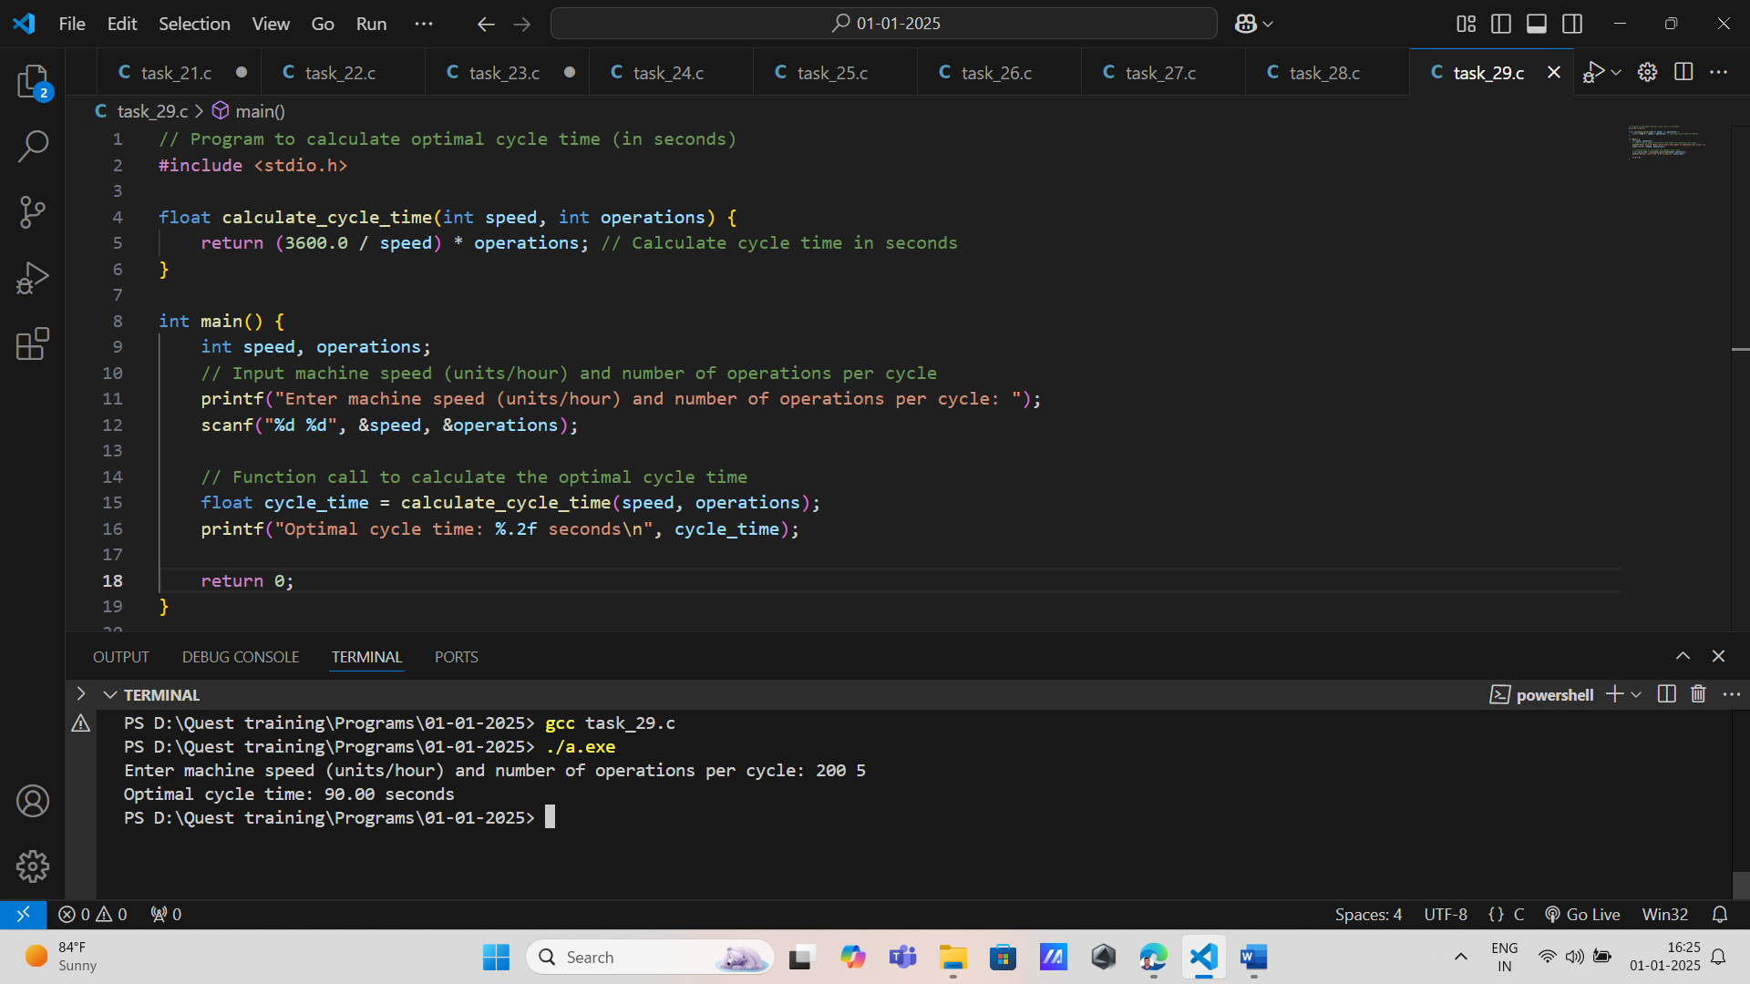

**1.**Write a function that takes the original price of an item and a discount percentage as parameters. The function should return the discounted price without modifying the original price.

**Function Prototype:** **void** calculateDiscount(**float** originalPrice, **float** discountPercentage);

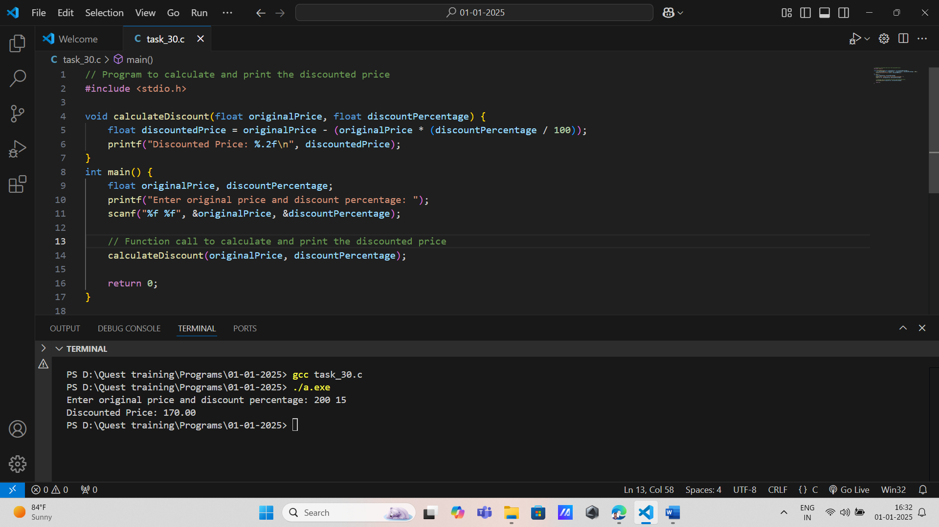

**2.**Create a function that takes the current inventory count of a product and a quantity to add or remove. The function should return the new inventory count without changing the original count.

**Function Prototype:** **int** updateInventory(**int** currentCount, **int** changeQuantity);

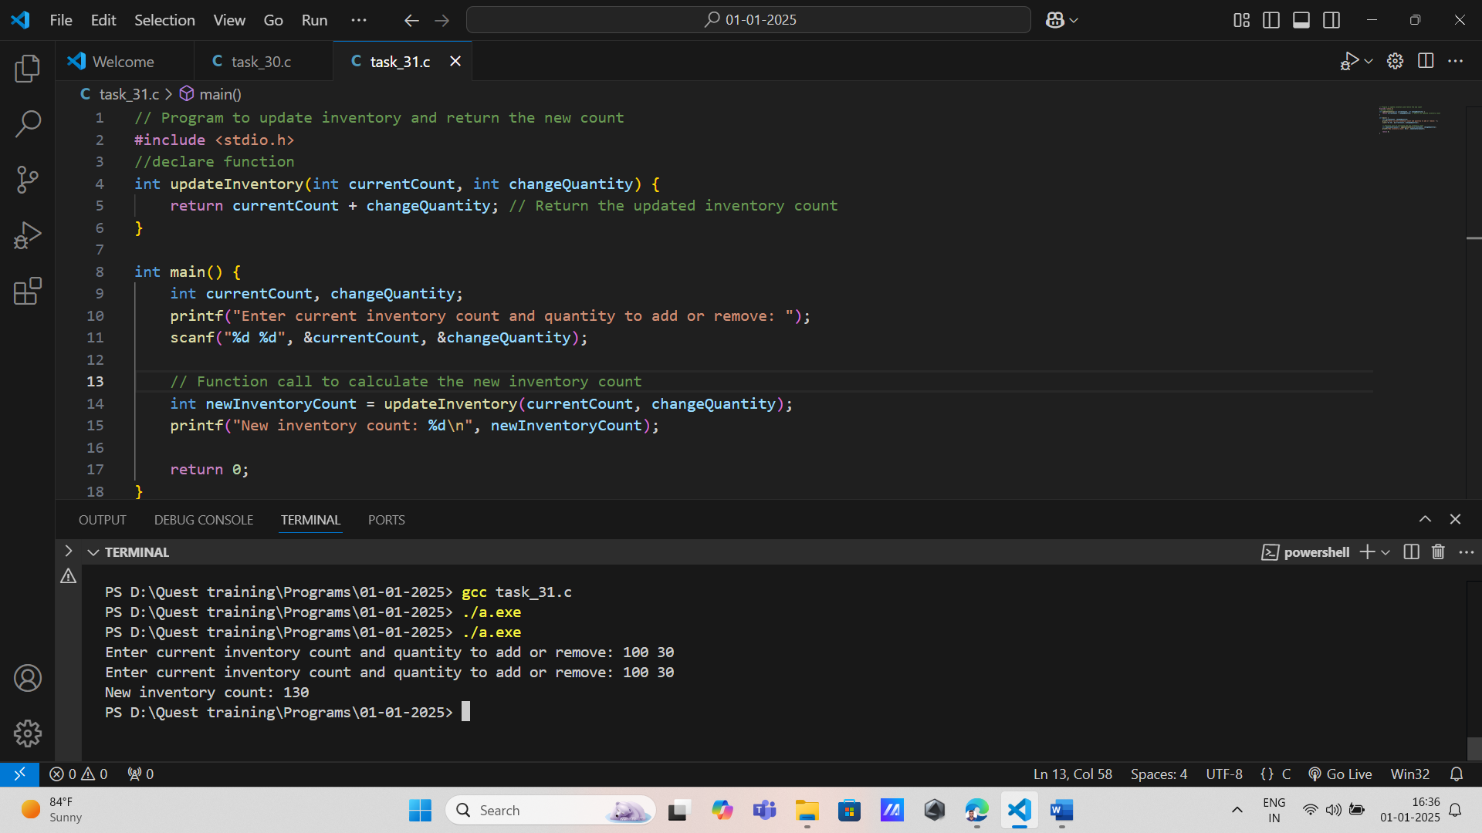

**3.**Implement a function that accepts the price of an item and a sales tax rate. The function should return the total price after tax without altering the original price.

**Function Prototype:** **float** calculateTotalPrice(**float** itemPrice, **float** taxRate);

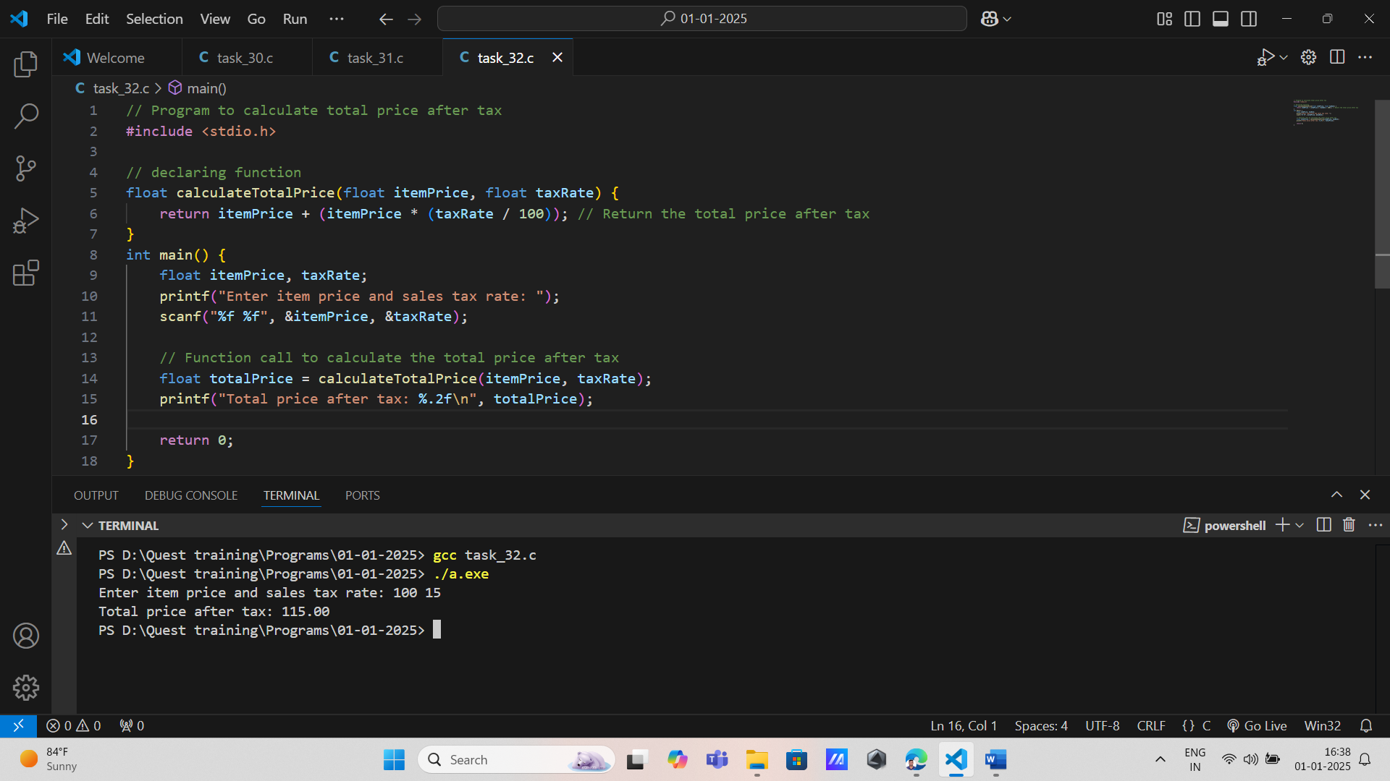

**4.**Design a function that takes the amount spent by a customer and returns the loyalty points earned based on a specific conversion rate (e.g., 1 point for every $10 spent). The original amount spent should remain unchanged.

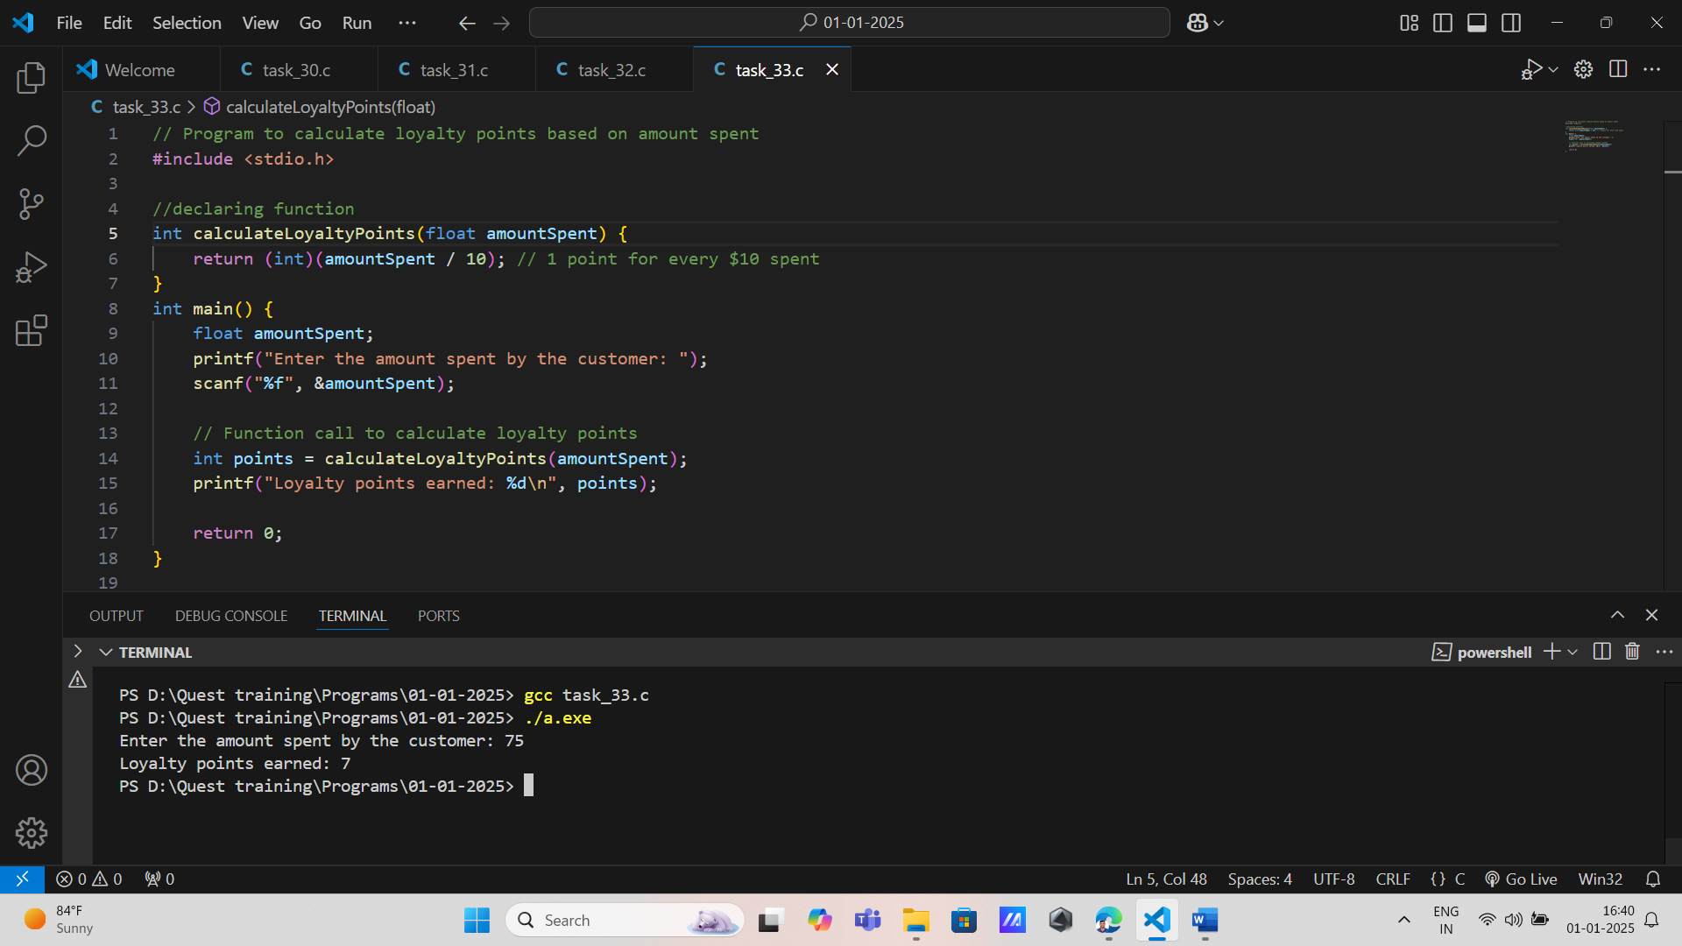

**5.**Write a function that receives an array of item prices and the number of items. The function should return the total cost of the order without modifying the individual item prices.

**Function Prototype:** **float** calculateOrderTotal(**float** prices[], **int** numberOfItems);

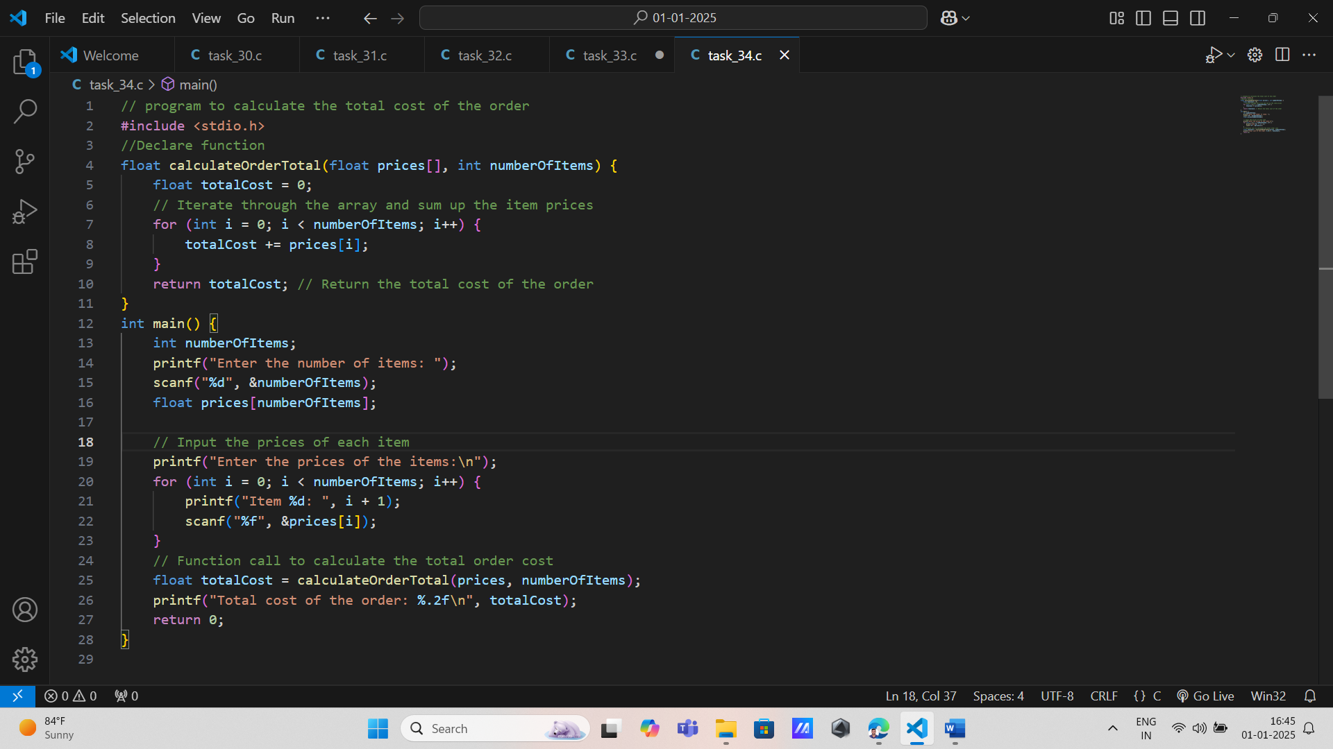

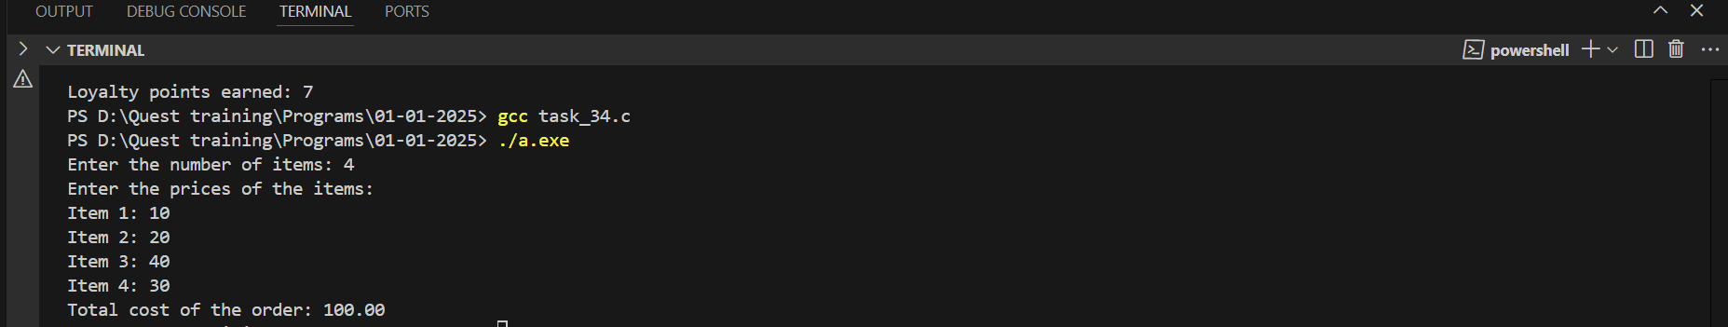

**6.**Create a function that takes an item's price and a refund percentage as input. The function should return the refund amount without changing the original item's price.

**Function Prototype:** **float** calculateRefund(**float** itemPrice, **float** refundPercentage);

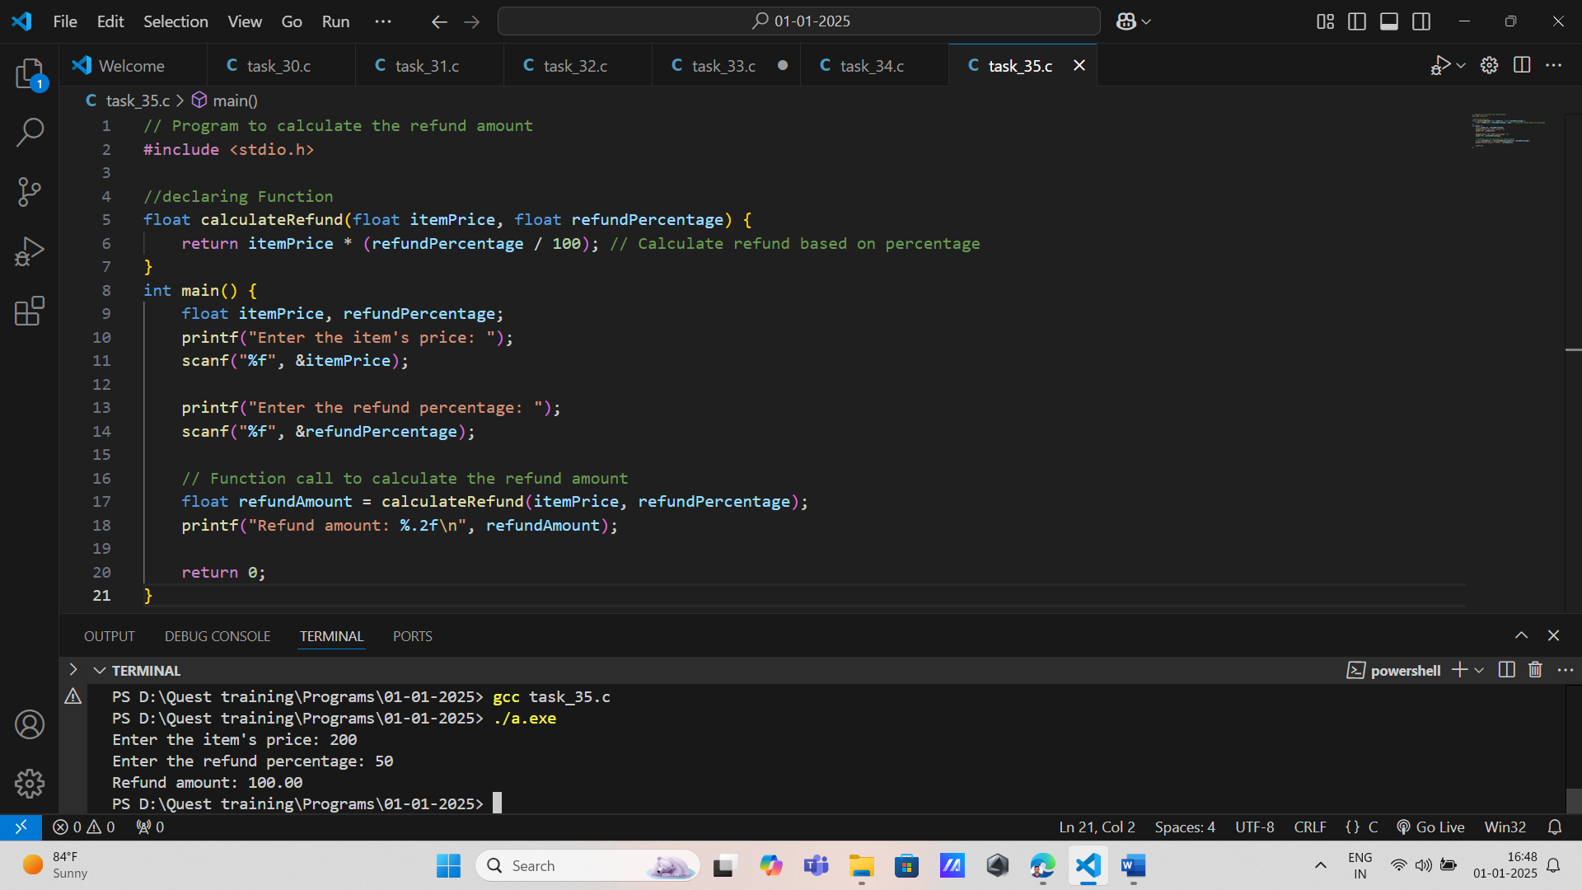

7. Implement a function that takes the weight of a package and calculates shipping costs based on weight brackets (e.g., $5 for up to 5kg, $10 for 5-10kg). The original weight should remain unchanged.

**Function Prototype:** **float** calculateShippingCost(**float** weight);

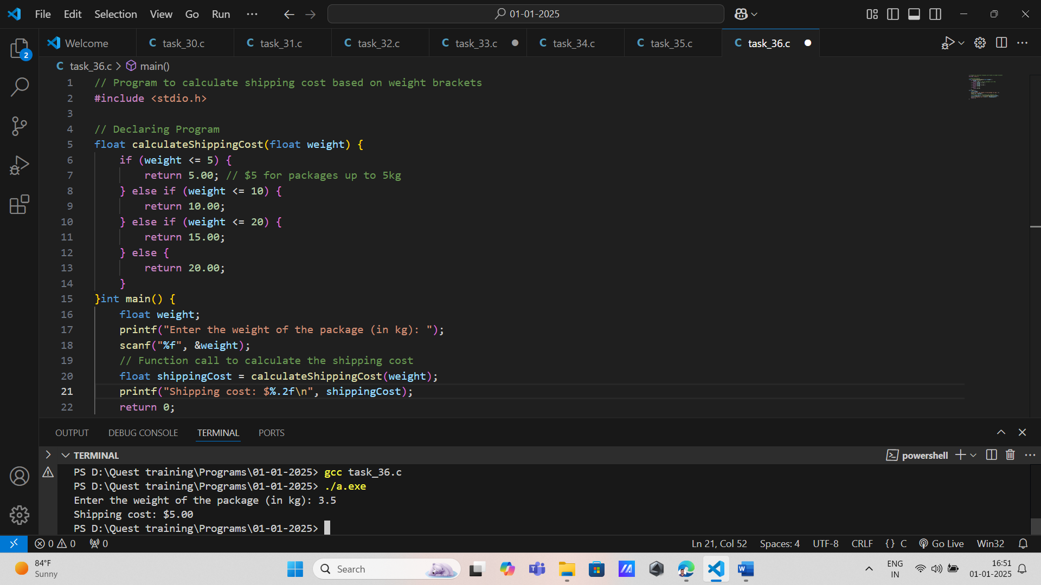

**8.**Design a function that converts an amount from one currency to another based on an exchange rate provided as input. The original amount should not be altered.

**Function Prototype:** **float** convertCurrency(**float** amount, **float** exchangeRate);

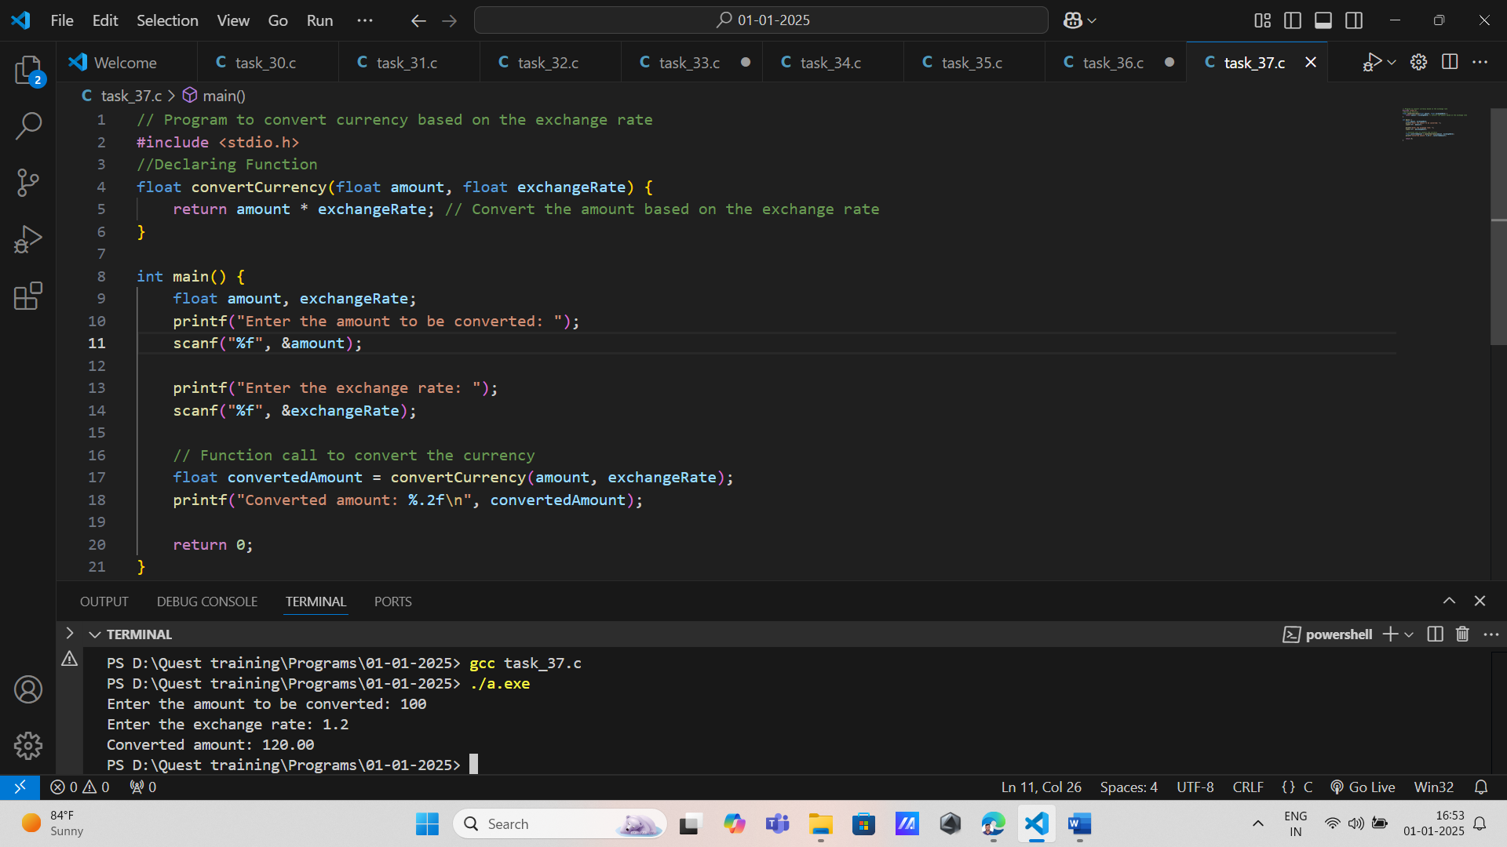

**9.**Write a function that takes two prices from different vendors and returns the lower price without modifying either input price.

**Function Prototype:** **float** findLowerPrice(**float** priceA, **float** priceB);

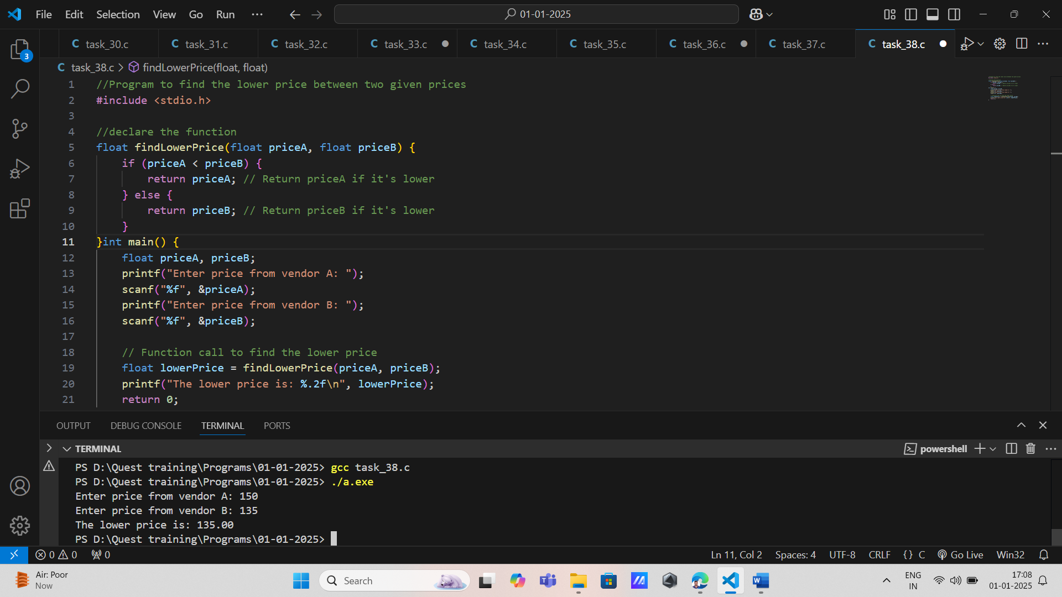

**10.**Create a function that checks if a customer is eligible for a senior citizen discount based on their age. The function should take age as input and return whether they qualify without changing the age value.

**Function Prototype:** **bool** isEligibleForSeniorDiscount(**int** age);

